MAINLAND HIGH SCHOOL
AIR FORCE JUNIOR ROTC
CADET GUIDE

Distinguished Unit W/Merit
2009-2010, 2010-2011, 2012-2013, 2015-2016, 2018-2019, 2023-2024, 2024-2025

Distinguished Unit

2011-2012,2013-2014, 2014-2015, 2016-2017, 2017-2018, 2019-2020, 2020-2021 COVID, 2021-2022, 2022-2023

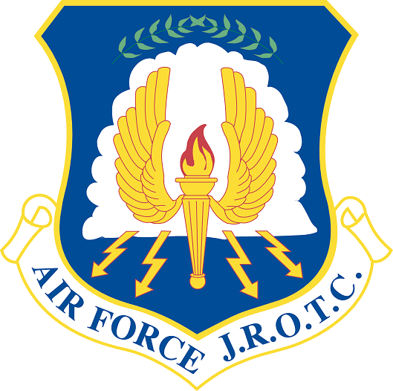

AIR FORCE CORE VALUES
INTEGRITY FIRST: SERVICE BEFORE SELF: EXCELLENCE IN ALL WE DO

AFJROTC MISSION STATEMENT
DEVELOPING CITIZENS OF CHARACTER

AFJROTC CADET CODE
“I WILL NOT LIE, CHEAT, OR STEAL NOR TOLERATE THOSE WHO DO.”

FL-042

DAYTONA BEACH, FLORIDA
August 2025

AFJROTC Cadet Staff
2025-2026

Commander
C/Lt Col Journey Smith

Vice Commander
C/Major Adrian Fortier

First Sergeant
C/MSgt Weston Tucker

Operations Officer
C/Maj Serena Sutherland

Mission Support Officer
C/Capt Tahleisha Thompson

Personnel Officer
C/Capt Sara Bowers

Personnel Assistants
C/2Lt Bao Nguyen
C/2Lt Lathan Gibson

Logistics Officer
C/Capt Tristan Acevedo

Logistics Assistant
C/2Lt Scott Wright

Health and Wellness Officer
C/1Lt Taliya Clarke

Historian
C/1Lt Madison Brown

Recruiting/Cyber Officer
C/1Lt Talayah Smith

Staff Assistant
C/2Lt Tammye Romano

Staff Assistant
C/2Lt Kenneth Girlardo

TABLE OF CONTENTS

CHAPTER ONE Page
AFJROTC Mission and Curriculum 1-1
-- AFJROTC Mission 1-1
-- Aerospace Science/Leadership Education Curriculum 1-1
-- Wellness Program 1-2

CHAPTER TWO
Grading Procedures 2-1

CHAPTER THREE

Admission, Transfer, and Disenrollment of Cadets 3-1

CHAPTER FOUR
Conduct, Integrity, and Military Courtesy 4-1
-- General Conduct/Bullying 4-1
-- Reserve Cadet Participation 4-1
-- Classroom Conduct 4-2
-- Military Courtesy and Saluting 4-2
-- Integrity 4-3

CHAPTER FIVE
Uniform Policy 5-1
-- Clothing and Equipment Account 5-1
-- Uniform Policy 5-1
-- Wear of the Uniform 5-2
-- Unauthorized Wear of the Uniform 5-2
-- Military Appearance 5-3
-- Insignia, Badges, and Shoulder Cords 5-4
-- Wear of Ribbons and Medals 5-6
-- Insignia and Uniform Illustrations 5-6

CHAPTER SIX
Activities 6-1
-- AFJROTC Activities 6-1
-- Leadership Development Requirement Activities 6-1
-- Field Trip Criteria 6-1
-- Fund Raising 6-2
-- Cadet Corps Activities 6-2

CHAPTER SEVEN
Cadet Evaluations/Promotions 7-1
-- Cadet Performance Report 7-1
-- Cadet Counseling 7-1
-- Cadet Boards 7-1
-- Promotion of Cadets 7-2
-- General 7-2
i

-- Promotion System 7-2
-- Selection Criteria 7-3
-- Policies 7-3
-- Demotion of Cadet Officers and NCOs 7-4

CHAPTER EIGHT
Awards and Decorations 8-1
Scholarship Money/Shadow Boxes/Graduation Cords 8-11

CHAPTER NINE
Cadet Staff/Officer/NCO Authority and Staff Responsibilities 9-1
-- Cadet Staff Selection 9-1
-- Cadet Officer/NCO authority and Limitations 9-1
-- Chain of Command 9-1
-- Cadet Command/Staff Responsibilities 9-2
-- Cadet Staff Duty Descriptions 9-3

CHAPTER TEN
Classroom, Supply Room and Cadet Staff 10-1

APPENDIX
Unit Manning Document A-1
Abbreviations A-2
Air Force Song A-3
Airmen’s Creed/Pledge of Allegiance A-4
Cadet Performance Report A-5
Grooming and Appearance Standards A-6
Badges/Insignia/Pins A-7
AFJROTC Ranks A-8
Uniform Standards A-9
Gigline A-10
How to Tie a Tie A-11
Military Time/Phonetic Alphabet A-12
30 Command Drill Sequence A-13 AFJROTC Cadet Creed A-14 Cadet Contract A-15 AFJROTC Ribbon Chart A-16

ii
CHAPTER ONE

AFJROTC Mission and Curriculum

AFJROTC Mission

1-1. The mission of the Air Force Junior Reserve Officer Training Corps (AFJROTC) Program is to acquaint high school students with the aerospace age, to develop informed citizens, to develop and strengthen character, and to promote an understanding of their role as citizens in a democratic society.

Aerospace Science & Leadership Education Curriculum

1-2. AFJROTC is a four-year hands-on course for high school students. The curriculum includes Aerospace Science, Leadership Education, and Wellness. Cadets can participate in numerous after-school activities to include: competition drill/color guard teams; numerous field trips; participation in many community service activities; rocket club; physical fitness club; and can take on key leadership positions. The following courses may be taught during a cadet’s time in AFJROTC.

Aerospace Science
a. AS 100: Milestones in Aviation History
b. AS 200: The Science of Flight: A Gateway to New Horizons
c. AS 220: Cultural Studies: An Introduction to Global Awareness
d. AS 300: Exploring Space: The High Frontier
e. AS 400: Management of the Cadet Corps
f. AS 410: Survival: Survive/Return

Leadership Education
a. LE 100: Traditions, Wellness, and Foundations of Citizenship
b. LE 200: Communication, Awareness, and Leadership
c. LE 300: Life Skills and Career Opportunities
d. LE 400: Fundamentals of Management
e. Drill Curriculum

1st, 2nd, 3rd, 4th year cadets | All 4 levels of cadets are in the same class.  Leadership Education: cadets learn about: drill, AFJROTC history, customs and courtesies, leadership, followership, rank and rank structure, military structure, uniform wear, communication & physical fitness.  Aerospace Science: cadets learn about: weather; aviation history; flight fundamentals; Orienteering; or global awareness.  Additionally, briefers from different backgrounds are a key component of this class.
3rd & 4th year –  cadet staff | Juniors & seniors with prior AFJROTC experience are competitively selected for our 7th period staff class. With a structure similar to the Air Force, these cadets are the key decision makers that help run our program. These cadets also earn an honors credit.
1-1
1-3. Wellness Program . The Wellness program is an ever-evolving program that alternates between team sports and workouts. The Wellness program includes jogging/running. The Wellness officer will plan the weekly sessions. Wellness sessions will be led by the flight Wellness sergeant. Wellness sessions will be held every Friday, unless you are told otherwise by the SASI/ASI. You will wear appropriate gear (AFJROTC t-shirt/shorts/sweats issued). Wellness counts as 20% of your grade. You can miss one (1) session with a note from your parent/guardian. You must then bring in a note from a doctor. NO NOTE – NO EXCUSE!

a. You will be evaluated by completing the Physical Fitness Test during the first and last 9-week period. This will be completed according to AFJROTC standards.

b. During Wellness sessions, cadets will form a circle around the Wellness Sergeant, stretch and then compete in the sport/workout of the week.

c. Changes to the Wellness program can be made by the Senior Aerospace Science
Instructor (SASI)/Aerospace Science Instructor (ASI) at any time.

1-2
CHAPTER TWO

Grading Procedures

It is imperative that cadets take part in all aspects of AFJROTC. The following is a guide for earning an appropriate grade

2-1. Grades are determined on the following basis for each 9-week grading period:
  - Approximately 40% from AS class to include tests, homework, and classwork
  - Approximately 40% from LE to include tests, uniform wear, and drill and ceremonies.
  - Approximately 20% for Wellness to include uniform wear.

2-2. Participation and attendance are critical to your success.
- A cadet must participate in all AFJROTC activities to include Aerospace Science class, Leadership Education class, and Wellness sessions.
- You must be excused if you miss a graded day. No excuse = Zero.

2-3. Uniform Grades.
a. Uniform wear is your primary grade in AFJROTC. Failure to wear the
uniform 3 times may cause your removal from AFJROTC.
- Failure to wear the uniform – 1st offense = 0, 2nd offense = -10,
3rd offense = -20, etc.

2-4. Wellness Grading Criteria:
a. 20 points total

10 points- Dress Out 10 points- Participation
10 points – Properly dress out 10 points – 100%
5 points – Missing PT shirt or shorts 5 points – 50%
0 points – Failure to wear proper shoes 0 points – 0%

2-5. Drill Grading Criteria:
a. 20 points per day. If you march you receive full points. If you don’t march you receive a zero. (Must wear closed-toe shoes/crocs acceptable)

2-6. Cadets MAY be granted time to make up any of these graded areas. The cadet must discuss this with the SASI/ASI in advance and it is up to the SASI/ASI whether to allow this to occur based on available dates and their schedules.

2-1
CHAPTER THREE

Admission, Transfer, and Disenrollment of Cadets

3-1. Eligibility. To be eligible for membership and continuance in the AFJROTC program, each cadet must be:

a. Enrolled at Mainland High School (MHS).

b. A citizen of the United States.

c. Of good moral character.

3-2. Transfer cadets from Army, Navy, Marine Corps or other Air Force JROTC units will be admitted with full credit for training already received. Rank will be determined on a case-by-case basis.

3-3. Cadets will not be disenrolled from the AFJROTC program without the approval of the SASI. A cadet may be disenrolled for the following reasons:

a. Failure to maintain acceptable course standards, specifically: improper attitude; poor AFJROTC academic standing (GPA below 2.00 after one semester should be allowed to reenroll if the GPA is raised), unless waived by SASI/ASI; consistently failing to meet AFJROTC grooming standards, and improper wear of the uniform; not wearing the uniform when required; lying, cheating, stealing, or failure to meet the responsibilities of a cadet.

b. Disruptive behaviors in any Mainland class that result in continued school disciplinary action, i.e., suspension. Cadets sent to ISS or suspended can lose their leadership position.

c. Individual cadet request for a course change within 7 days into the new semester.

d. Any other behavior unbecoming of an AFJROTC Cadet as determined by the SASI.

3-4. Each cadet must comply with the rules and regulations of the Aerospace Science Department and must accept responsibility for the care and maintenance of the USAF uniform, textbooks, other U. S. government and Volusia County property.

3-5. Upon enrolling and continuing in the cadet corps, each cadet agrees to the FL-042 AFJROTC Cadet Contract. (Attachment 16)

3-1

CHAPTER FOUR

Conduct, Integrity and Military Courtesy

4-1. General Conduct: Poor or questionable conduct is not an attribute of an AFJROTC cadet and is not tolerated in the Cadet Corps. All cadets are expected to adhere closely to the AFJROTC Cadet Code (Front Cover) and high personal standards both in and out of uniform. The behavior of every cadet is a reflection on the USAF, FL-042 AFJROTC Cadet Squadron, and MHS and is expected to be above reproach at all times. There are several policies with regard to conduct that an AFJROTC cadet needs to pay particular attention to.

a. Public display of affection or aggression (PDA) while in uniform, except in the context of a military social event like the Military Ball, is not allowed. This includes kissing, hand holding, and all other forms of physical affection/aggression.

b. The use of inappropriate language in or out of uniform is not professional. Cadets will not use abusive, vulgar, obscene, or profane language.

c. Cadets will not annoy or harass other students/cadets with insulting, inflammatory, insinuating or defaming remarks, or obscene gestures. Cadets will not indulge in horseplay such as hitting, slapping, sparring, or wrestling.

d. Taking part in public demonstrations that do not agree with the principles of the USAF, AFJROTC, or MHS while in uniform, even for a "good" cause, is inappropriate and must be avoided.

e. Bullying of any kind WILL NOT be tolerated. Hazing of any kind to include any type of physical punishment—i.e. push-ups, etc, is NEVER tolerated. Either should be immediately reported to the SASI/ASI and may be referred to the Dean’s Office.

f. Reserve Cadet. A Reserve Cadet is basically a cadet who cannot enroll in AFJROTC courses within the school and is in the AFJROTC program for the sole purpose of participating in co-curricular (after school) activities. To qualify as a Reserve Cadet, a student will meet one of the following criteria, with SASI concurrence:

(1) The student has completed the entire AFJROTC Academic Program at the school and cannot continue without duplicating curriculum courses.

(2) The student is in a Traditional scheduled school, but cannot participate in the AFJROTC academic program for that particular year due to only duplicated courses being offered.

(3) A student must have been a cadet for at least one academic year (academic term for 4x4) prior to being considered a Reserve Cadet.

4-1

(4) Reserve Cadets may participate in all AFJROTC activities (community service, drill team, honor guard, etc.). Time in reserve status does not count towards the Certificate of Completion, nor do Reserve Cadets count toward minimum unit enrollment or unit funding. Reserve Cadets may retain their uniform for the entire academic year.

(5) Units must accurately report the total number of active cadets within their program on PSR reporting dates in October and February. Additionally, WINGS will be updated within 10 calendar days of any change. Accurate accounting is essential to ensure units are funded correctly and minimum viability is met.

4-2. Classroom Conduct:

ALL headphones will be removed, and ALL electronic devices will be put away, prior to entering the AFJROTC classroom

a. Upon entering the AFJROTC classroom, stand quietly behind your assigned seat, with the chair pushed in. When the tardy bell sounds, the flight assumes “Parade Rest”. When the Flight Sergeant (FS) calls your name, come to attention, state the designated phrase, and assume “Parade Rest” again. Once the FS is done with roll call, they will give the command “Flight, Attention”. The FS will then report to the Flight Commander (FC), and the FC will seat everyone.

b. The FC reads daily announcements and/or conducts flight business.

c. The FC reports to the instructor – “All present and/or accounted for”.

d. If you wish to speak, raise your hand.

e. Food (including gum) will not be permitted in the classrooms. Only drinks with a screw on lids are allowed in class.

f. No cell phones or other electronics devices will be used during class time. Devices may be used when the Major or MSgt allow it.

g. No candy sales, fund raising, campaigning, or related activities are permitted during class time.

h. Conduct in the AFJROTC class is based on one simple rule: Respect one another.

4-3. Military Courtesy and Saluting: Cadets will use "Yes, Sir/Ma'am/Sergeant", and "No
Sir/Ma'am/Sergeant", when responding to their instructor and cadet officers. When in uniform and wearing a hat outside, cadets will salute the SASI and cadet officers. Cadets will not render the salute while using the stairs.

a. The salute, in various forms, is a courteous exchange of greeting used in militaries all over the world. In many countries, as in our nation, it is a symbol of respect. The salute is among the oldest traditions binding military professionals together.

4-2

b. You will be taught the proper manner for saluting and the rules that govern its use among military services. There are special rules at MHS governing the salute and saluting areas with which you must become completely familiar.

(1) FL-042 cadets salute at MHS when in uniform and out-of-doors adjacent to the school. This policy includes going to/from classes, and in the bus loop, among others. Cadets also salute at military installations, in unform, when on field trips.

(2) Cadets will render the salute indoors when in formation or participating in ceremonies, or when reporting to cadet officers, or the SASI/ASI. The proper sequence for reporting includes the rendering of the salute and the statement "Sir, Cadet (last name) reporting as ordered," or as appropriate. The cadet holds the salute until it is returned. When the meeting is concluded, the cadet salutes to terminate the session.

(3) The school's gym is "indoors", and saluting is not required unless the cadet is covered and under arms. In this case saluting is required, to include rendering "Present Arms" to the "colors" during the play of the National Anthem.

(4) A salute is never given or returned while running. The cadet will come to a quick walk and, render the salute when approximately six paces from the officer.

(5) Cadets not in uniform may render the salute as if they were in uniform, if desired.

(6) Cadet Airmen, NCOs, and junior officers will salute cadet senior officers. The junior cadet will initiate the salute and greeting, which will be courteously returned by the senior cadet officer.

(7) If a cadet, in uniform, observes the American Flag being raised or lowered from any flag pole, he/she will assume the position of attention, render the hand salute and hold it until the flag has reached the summit or base of the staff. If the cadet is in civilian clothes, he/she will assume the position of attention with the right hand over the heart. If a male cadet is wearing civilian headgear, he will remove it and hold it to his left shoulder so that the right hand is over the heart. It is mandatory for a cadet to stand for the pledge of allegiance.

(8) When a cadet is late for a formation, he/she will approach the individual in charge when the formation is halted. The tardy cadet will salute, and request permission to "fall in."

(9) Cadet Officers should correct saluting violations in a courteous and helpful manner when junior cadets make such violations.

4-4. Integrity: High standards of integrity are required of all cadets. This means that one takes responsibility for their own actions, does not purposely use others for personal gain, and does not compromise the AFJROTC Cadet Code. Integrity also involves adhering to strong moral values, both in and out of uniform. These values are a reflection of the pride we have in our country and ourselves.
4-3

CHAPTER FIVE

Uniform Policy

5-1. Clothing and Equipment Account: The USAF issues all parts of the AFJROTC uniform, with the exception of the shoes and socks, on a loan basis. These items remain the property of MHS and the USAF. All uniforms and equipment must be accounted for at all times.

a. One complete uniform with all the accessories and insignia will be issued to each cadet who meets grooming standards (Attachment 6). At the time the uniform is issued, each cadet will be required to sign a Custody Receipt Form. Each uniform item then becomes the personal responsibility of the cadet. All items issued (except shoes and socks) will be returned or paid for at the end of the school year. NOTE: Volusia County policy requires a "hold" on a student's school records until all AFJROTC equipment has been returned or paid for in full. Necessary uniform alterations will be provided by the Air Force. Minor repairs such as loose buttons, open seams, etc., are the responsibility of the cadet. If a cadet should lose or destroy any part of the uniform, then that cadet will be required to pay for a replacement item at the established price.

(1) DO NOT leave uniform items in unattended places.

(2) DO NOT lend uniforms to anyone.

(3) DO NOT permit another cadet or person to turn in uniform items.

(4) DO NOT carry flight caps with books. If not being worn, the cap should be tucked under the belt on the left side.

(5) DO return any found equipment items to any Logistics representative.

(6) DO return any items that become worn or unserviceable to Logistics. If the unserviceable item is due to normal use, the items will be replaced at no cost. Any item that does not fit properly should be returned as soon as possible. Remember you represent the USAF in public so look your best by
maintaining your uniform in the best possible condition.

5-2. Uniform Policy: The Air Force uniform in the combination prescribed by the Squadron Commander, in coordination with the SASI/ASI, will be worn every WEDNESDAY, for the entire school day. The uniform day may be changed as necessary by the SASI/ASI.

a. If a cadet cannot wear the uniform on the specified uniform day for any reason, the
cadet must receive prior permission, from the SASI/ASI, to wear it on an alternate day.

b. Any cadet present on Wednesday and not in uniform, will receive a ZERO for that uniform grade, unless they have a note. They will then wear the uniform the next school day. Repeated failure to wear the uniform or failure to follow grooming guidelines will result in the cadet being removed from the AFJROTC program. (Cadets will also receive a ZERO for that day if they change out of uniform (prior to or following AFJROTC class) without permission of the SASI/ASI .
5-1

c. Wearing of hats in uniform: Hats will be worn in uniform, outside, at all times. In keeping with the "no-hat" policy at MHS, the uniform hat will not be worn in any classroom except for special formations as designated by the SASI. Hats, when not worn will be placed under the belt, on the left front side of the body, between the belt loops. Hat will not be doubled over the belt.

5-3. Wear of the Uniform:

a. Cadets will wear the standard service uniform prescribed in AFJROTCI 36-2010 and AFI 36-2903 for active duty personnel. It is the cadet's responsibility to maintain all uniform items in a clean and orderly condition during the school year. Shirts will not have military creases.

b. Cadets must wear the prescribed AFJROTC uniform. Operational Camouflage Pattern Uniforms (OCPs) are authorized to be worn on Wednesday, twice a month by Cadet Staff personnel only, with permission of the Principal. Exceptions may be approved by SASI/ASI.

c. Cadets may not wear USAF commissioned officer sleeve braid nor officer silver thread on flight caps.

d. Color Guards and drill teams may wear additional uniform items, insignia, and devices.

e. AFJROTC cadets will wear the distinctive uniform required for special occasions and ceremonies.

5-4. Unauthorized wear of the uniform:

a. No item of the USAF uniform is authorized for wear by members of FL-042 AFJROTC Cadet Squadron with civilian clothing. This includes officer and NCO rank items. (Exception: Cadets can wear the zip-up jacket without rank, if the jacket does not have the USAF symbol.)

b. Cadets will not wear the uniform while participating in student demonstrations, for crowd control, or in any other inappropriate activity. AFJROTC cadets may wear the cadet uniform while acting as ushers, parking lot attendants, runners, and at weddings and
funerals, etc., at the discretion of the SASI/ASI.

5-5. Military Appearance:

- Basic concept. The AFJROTC cadet uniform is the same as that worn by active duty
USAF personnel, with the only difference being the insignia and patch. Because it is the distinctive dress of a proud and honorable profession, the uniform must be worn correctly and properly maintained.

5-2
b. Standards of Personal Appearance. Each cadet must maintain high standards of dress
and personal appearance. It is imperative for all cadets to present a neat and well- groomed appearance to their fellow citizens. Uniforms must be kept neat, clean, correct in design and specifications, and in good condition. Personal cleanliness is a must for every cadet.

c. Uniform Cleaning and Care.

IF IT IS DARK BLUE YOU MUST DRY CLEAN IT!

(1) Service Coat, Lightweight Jacket, and pants: Dry clean only. Under no circumstances will this uniform be washed.

(2) Blue shirts: Dry clean or wash as desired, giving particular attention to the collar and cuffs. Shirts may be starched. Use no bleach except that which is designed for use with colored garments.

(3) Flight caps: Dry clean only.

(4) Neckties: Dry clean only.

(5) Belt: May be dry-cleaned or scrubbed with a soft brush and mild detergent.

d. AFJROTC cadets must comply with the following standards:

(1) Uniforms will be kept buttoned; shoes will be shined and kept in good repair. Badges, insignia, belt buckles and other metallic devices must be maintained in the proper luster and condition.

(2) Optional items. If issued, the lightweight jacket will be worn zipped up at least halfway and will have proper insignia.

(3) Males. The fitting standards, wearing instructions, and personal grooming standards are those prescribed in AFI 36-2903. (Attachments 6 and 9)
- Uniform. Articles such as wallets, pencils, pens, watch chains,
jewelry, handkerchiefs, combs, lanyards, and sunglasses will not be carried exposed on the uniform. Cadets may wear wristwatches, rings, and identification bracelets. Conservative sunglasses may be worn, but not in military formation or in the classroom. Males will not wear earrings. T-shirts will not be visible with open collar uniform combinations.

(4) Females: The fitting standards, wearing instructions, and personal grooming standards are those that are prescribed in AFI 36-2903. (Attachments 6 and 9)

5-3

(a) Uniform: Articles such as pencils, pens, jewelry, handkerchiefs, combs, and sunglasses will not be carried exposed on the uniform. Cadets may wear wrist watches, rings, lanyards, and identification bracelets. Female cadets may wear conservative round diamond, pearl, gold or silver spherical earrings (6mm). Only one earring per ear may be worn, in the lower earlobe. Hoop earrings of any size are not allowed. Conservative sunglasses may be worn, but not in military formation or in the classroom.

(b) Panty Hose: Panty hose will be a shade which complements the uniform. May be worn with skirt.

(c) The SASI/ASI may authorize wear of the blue service uniform with a white shirt or over blouse with a blue tab, or a civilian evening gown on appropriate occasions.

(5) Removal of coats: Cadets are authorized to remove their coats in the classroom if they ask permission of the instructor. The coats will be placed on the back of the chair. Under no circumstances will the coat be worn unbuttoned. Ties will not be loosened.

(6) Use of personal electronic media devices, including cellular phones, earpieces, speaker phones or text messaging while walking in uniform is authorized. Military customs and courtesies take precedence.

5-6. Insignia, Badges, and Shoulder Cords: This Guide covers the authorized badges and insignia to be worn by AFJROTC cadets.

a. Name Tags: Each cadet will be issued one standard plastic USAF blue nametag with the name engraved and one metal USAF silver nametag with the name engraved.

b. Aerospace Education Foundation (AEF) Academic Cadet Award.
Awarded to rising Junior and Senior cadets for academic excellence. Cadets must attain an overall 3.3 grade point average with no grade below a 2.0 on their transcript. The individuals must be recommended by the SASI.

c. Distinguished AFJROTC Cadet Award. This annual award consists of a certificate and a Distinguished AFJROTC Cadet badge. The award recognizes one outstanding third-year cadet. Selection is made at the end of each school year. This allows the recipient to wear the award throughout their final year in the AFJROTC program. The recipient must be of high moral character, demonstrate positive personal attributes, display outstanding military potential, and maintain consistent academic and military excellence. The recipient must also hold the following awards prior to selection: The SASI, with the concurrence of the principal, selects the recipient.

5-4

Leadership ribbon
Achievement ribbon
Superior performance ribbon
Academic ribbon
Co-curricular activities leadership ribbon
Service ribbon

d. Awareness Presentation Team Badge: Awarded for participation on an Awareness Presentation Team. Criteria for becoming a team member: Attend 75% of all meetings
and attend at least one school briefing in order to earn the badge.

e. Kitty Hawk Honor Society Badge: Awarded to cadets who meet the criteria to be members of the Kitty Hawk Honor Society. Criteria for becoming a member: have and maintain a 3.0 GPA, attend 75% of all meetings, participate in one event, and complete the Kitty Hawk Honor Society contract. Badge may be revoked if cadet fails to maintain KHHS standards.

f. Model Rocketry Badge: Awarded to cadets who have fulfilled model rocketry program requirements. Program requirements are listed in the Model Rocketry Handbook available in WINGS.

g. AFJROTC Shoulder Patch: Wear of the AFJROTC official shoulder patch is mandatory on all uniforms except the raincoat, overcoat, all-weather coat and ABU (front left pocket only). Cadets enrolled in Civil Air Patrol (CAP) and AFJROTC who use the same uniform for both activities may wear the CAP wing patch on the right shoulder and the AFJROTC patch on the left shoulder with the AFJROTC shoulder patch taking precedence.

h. Shoulder Cords: Cadets are authorized to wear one shoulder cord (double knot, single cord – no auguillettes or citation cords) on the left shoulder. This will be a single “infantry” style cord, without metal tips, no more than 1-inch wide. Wear the shoulder cord only on the short or long sleeve light blue shirt and the service dress coat. On the service dress coat, cords should be pinned near the shoulder seam with the pin hidden beneath the cord. The ASI will designate criteria for wear. Specific designations are:
(1) Commander/Vice Commander/First Sergeant/Special Asst. – Silver
(2) Ops/MSO/Pers/Log Officers – Purple
A. Personnel/Logistics Asst - _____________
(3) PT/Rec/Hist/Cyber – Yellow
(4) Staff Asst – Red
(5) Comp DT/CG/XDT/30 – Silver/Black, Blue/Silver, Blue/Yellow, White
(6) Morning Flag Team CC -- Burgundy
(7) Cadet of the Month – Gold

i. Wear of shoulder cords in uniform.

Coat:
Worn grounded on left shoulder seam of the coat.

5-5

Shirt:
Worn grounded on left shoulder seam. Enlisted personnel wear shoulder cord on top of epaulet, grounded to left shoulder seam when wearing summer uniform. Officers wear the shoulder cord under the epaulet, grounded to left shoulder seam when wearing coat and summer uniform.

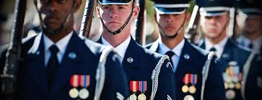

5-7. Wear of Ribbons and Medals:

a. Ribbons of other Services: AFJROTC cadets are NOT authorized to wear ribbons
earned while enrolled in the JROTC programs of other Services.

b. Regular size Medals and Ribbons: These may be worn simultaneously when authorized by the ASI for formal, semiformal, and special occasions. Medals and ribbons will not be worn together. The routine wear of medals is not authorized.

1. Medals. The top row of medals will be positioned ½ inch below the bottom row of ribbons. Medals will only be worn on the service coat on special occasions. (Determined by ASI)

5-8. Insignia and Uniform Illustrations: (Attachment 8)

5-6

CHAPTER SIX

Activities

6-1. AFJROTC Leadership Development Requirement (LDR) Activities: These are functions which cadets help plan, organize and execute activities. They also serve to augment AFJROTC classroom and leadership education requirements. They reinforce portions of the Aerospace and Leadership Education objectives. Example: The Military Ball not only serves to stimulate cadet’s esprit-de-corps, but also provides experience in Air Force traditions.

a. Leadership Development Requirement (LDR) activities. An LDR must be an AFJROTC after-school activity. These events must be Planned, Organized and Executed by cadets. They must be supervised by a certified AFJROTC instructor.

The following is a list of LDR activities that may take place every year.

Competitions Drill/CG Teams Bataan Death March
Military Ball Ceremonial Color Guards
Mainland March-Off Drill Meet Morning Flag Team
Rocket Club Awards Banquet and Ceremony
Kitty Hawk Air Society Cadet Leadership Course
Academic Bowl Intra-Flight Challenge
Parades (3) Tri-School Challenge
PT Team PT Club
Morning Flag Ceremonies

b. The cadets, SASI/ASI, and school administration will develop guidelines and requirements for all LDR activities in the unit. Cadets will not be released at the event without prior written approval from the parent or guardian.

c. Cadets must meet school requirements and be approved by the SASI/ASI in order to participate in LDR activities.

d. During such activities, all cadets are expected to be in uniform unless instructed otherwise. Proper military customs and courtesies, such as saluting will be practiced.

6-2. Curriculum-In-Action (Field Trip) Criteria:

a. Curriculum-in-action (CIA) field trips are activities that are used to motivate and reinforce the learning activities of all cadets.

b. A CIA is a school activity; therefore, a parental consent form will be completed.

c. Any cadet with one or more referrals in 30 days may be ineligible.

d. Cadets’ teachers must sign the field trip form if event held during school hours.

e. A cadet who has a failing grade in AFJROTC is NOT eligible for field trips.

6-1
f. All assignments must be turned in.

g. Must wear AFJROTC uniform consistently.

h. Cannot miss more than 10 days of school in the grading period of the field trip.

6-3. Fund Raising: Fund raising activities are essential to the unit. They must conform to local ordinances and school policies. Cadets will not wear the AFJROTC uniform while conducting fund raising activities, unless approved by the SASI/ASI.

a. No cadet activities are completely funded by the school, Air Force, or outside organizations. Fundraising is essential to our program. Cadets are strongly recommended to help raise funds that ultimately help the cadets and corps participate in our numerous activities.

b. Donations and sale of approved items are sources of income necessary to have co-curricular activities and to purchase items required by the Cadet Squadron.

c. Any and all funds raised by the cadets through authorized activities must be turned in to SASI/ASI, and school officials in turn. Any personal use of funds raised is strictly prohibited.

6-4. Cadet Corps Activities. The value of the AFJROTC program depends on the amount of time and effort the individual cadet puts into the program. The return in benefit to you is directly proportional to your level of participation in the available Cadet Corps activities. Each cadet is encouraged to participate in one or more of the following activities:

a. Ceremonial Color Guard. This select group of teams has the honor of presenting the colors (U. S. and Florida flags) at important school and community events. Distinctive uniform items are authorized. There is mandatory practice once every nine weeks that all interested cadets must attend. An overall GPA of 2.0 is required for participation.

b. Competition Color Guard. This Color Guard competes with other units at organized meets. Distinctive uniform items are authorized, and membership is determined by try-outs. The Color Guard practices two times per week. An overall GPA of 2.0 is required for membership.

c. Drill Team (Regulation/Exhibition/Armed/First Year). The Drill Team is a precision marching unit that represents the Cadet Corps and the school in formal presentations, ceremonies, and competitions. Much extra effort is required in this activity. The Drill Team practices two times per week. Drill Team members refine the basic skills learned in leadership education drill and ceremonies, learn special drill maneuvers, extra care of the uniform, and the highest standards of discipline and teamwork. An overall GPA of 2.0 must be maintained for membership.

6-2
d. Rocket Club. Rocket Club members pursue the study of rocketry and rocket launching
beyond that offered to all students in the appropriate Aerospace Science course. Any cadet may join the Rocket Club. Club competitions may be held. Cadets who meet the AFJROTC established criteria are eligible for a Rocketry Badge to be worn on the AFJROTC uniform.

e. Kitty Hawk Honor Society. The Kitty Hawk Honor Society (KHHS) is the AFJROTC Honor Society. It is named after the site of the Wright Brothers first heavier-than-air powered aircraft flight at Kill Devil Hills in Kitty Hawk, North Carolina. Only the most dedicated, outstanding cadets are selected for membership by invitation into the Kitty Hawk Honor Society. The purpose of the Society is to recognize academic achievement and to bring together cadets who have a strong interest in the advancement of aviation, aerospace science, and the cadet corps. The goals of the Society are to:

(1) Promote higher academic achievement.

(2) Be of service to the school and community.

(3) Encourage further academic growth. Invitations for membership may be extended to those cadets who meet the basic AFJROTC enrollment criteria, and who have an overall GPA of 3.0. Members of the KHHS are authorized to wear a distinctive badge on the AFJROTC uniform.

(4) Pledge, initiation activities, projects, a constitution, sample correspondence, etc. materials are provided in separate documents pertaining to the Air Society.

f. Orienteering. Cadets are welcome to participate in orienteering competitions. Competitions consist of using a map and compass to find hidden markers in a wooded area. Cadets can wear the orienteering ribbon on their AFJROTC uniforms if they place in a competition. (Medals and trophies are also awarded to top performing schools and cadets.)

g. Physical Training (PT) Club. The physical training club is open to all cadets. Cadets participate in a variety of physical fitness activities. Cadets are authorized to wear the Wellness ribbon on their AFJROTC uniform upon successful completion of the program.

h. Cadet Leadership Course (CLC) (1 Week). This course takes place at The Citadel in Charleston, South Carolina. All cadets (except for seniors) are eligible to attend as first year cadets (basics) selected to attend. All cadets must meet rigorous physical and mental standards. Select second and third year cadets may return as Cadre. Activities at CLC include: drill, individual and room inspections, obstacle course, orienteering, marksmanship, team sports, raider challenge, and team leadership problems. Seniors are not eligible. The following criteria must be met to attend CLC:

6-3

Gender | Fees | 30 Command Drill | GPA | Mile Run | Push-ups | Sit-ups
Male, Basic | TBD | Memorized | 2.0 min | 8:00 | 30 | 30
Female, Basic | TBD | Memorized | 2.0 min | 10:00 | 15 | 30
Male, Cadre | TBD | Memorized | 2.5 min | 8:00 | 35 | 40
Female, Cadre | TBD | Memorized | 2.5 min | 10:00 | 20 | 40

6-4
CHAPTER SEVEN

Cadet Evaluations/Promotions

7-1. AFJROTC Cadet Performance Report:

a. At the end of the first semester and prior to the promotion board, cadets in leadership positions will rate their subordinates for possible advancement in rank and/or position assignment. The Cadet Performance Report (Attachment 5) will be used for these evaluations and will be placed in the Cadet's Record folder.

b. The Cadet Squadron Commander and Special Assistant to the SASI will be rated by the SASI.

c. The next higher official above the evaluator will endorse all evaluations and all evaluations will be reviewed by the SASI/ASI.

d. The Personnel Officer is responsible for the privacy and safekeeping of the Cadet Performance Report.

7-2. Cadet Counseling: As necessary for personal or disciplinary reasons, cadets may receive additional counseling from instructors or cadet supervisors.

7-3. Cadet Boards: Cadet board will consist of the CC, CV and 1Sgt.

a. Organize the promotion board at the end of the first semester

b. Recommend cadets for temporary promotion and/or position assignment. Command, staff positions and rank will be determined by SASI/ASI.

c. Recommend cadets for outstanding accomplishments in the areas of academic achievements, leadership, and other applicable areas of achievement.

d. Determine failure to meet standards of good conduct.

e. Keep written track of why cadet is not selected for promotion. All board members must sign record.

f. The findings and recommendations of cadet boards are always subject to approval by the SASI/ASI and will serve only as a basis for further action by the SASI. Reports will follow the formats provided by the SASI.

g. The SASI/ASI will be present during cadet boards to offer advice and assure proper procedures are followed. The board proceedings and results are considered to be confidential and will not be discussed outside of the board meeting. Violations of this directive may result in demotion in rank and removal from the cadet position held.

7-1

7-4. Promotion of Cadets

7-4.1. General: Promotion provides challenge and motivation to members of the active Air Force. Experience has shown that promotion also commands attention and respect from members of the AFJROTC. This attention and respect is proper since the insignia of promotion reflects visible evidence of growing maturity, the ability and willingness to accept additional responsibility, and a demonstrated growth of leadership. The insignia reflects an ability to direct others toward the attainment of objectives that result in effective organizational efforts.

Promotions are based on academic and leadership grades and on demonstrated abilities, as well as filling certain criteria. Each cadet should understand how selections for promotion and selection to various command and staff positions are made to permit an equal opportunity for qualification.

7-5. Promotion System: The promotion system is patterned after the active duty Air Force and conforms to guidance provided by HQ AFROTC. The following provisions apply:

a. There are two types of rank a cadet may hold, permanent grade and temporary grade.
In some cases, they may be held at the same time.

(1) Permanent Grade: This grade is fixed by AFJROTCR 36-2001 and is awarded for satisfactory progress in the AFJROTC program.

(a) The permanent grades authorized are:

1. AS I (First Year) - Cadet Airman
2. AS II (Second Year) - Cadet Airman First Class
3. AS III (Third Year) - Cadet Senior Airman
4. AS IV (Fourth Year) - Cadet Staff Sergeant

(b). Cadets will receive this permanent grade at the beginning of each school year, provided they have not done anything to hinder this decision.

(c). If a higher temporary grade has not been awarded, the insignia of the permanent grade will be worn.

(d). Retention of this grade is contingent upon satisfactory performance.

(e). Once officer/NCO status has been held for one semester, that cadet MAY remain an officer/NCO for the remainder of the time spent in the program.

(2) Temporary Grade:

(a) This grade is awarded based on demonstrated cadet performance and on the position to which the cadet has been assigned within the Cadet Squadron. Since the grade is temporary, it will not be carried over from one year to the next.
7-2

(b) Temporary grades are assigned only when they are higher than permanent grades. Therefore, a cadet who has both a temporary and a permanent grade will wear the higher insignia..

(c) Cadets serving in a temporary grade in a flight position will revert to their permanent grade upon completion of their duties (semester or annual rotation). This is a normal occurrence and is not to be considered a demotion.

(d) At the recommendation of the Squadron Commander and approval of the SASI, highly qualified graduating seniors may retain their temporary grade even if it is higher than that authorized for their present assigned position, regardless of course level.

b. Cadets initially assigned to command/staff positions will not be awarded the highest grade authorized. This permits promotion based on actual performance within the position. The Unit Manning Document (UMD) (Attachment 1) specifies the grades and positions applicable to the FL-042 AFJROTC Cadet Squadron.

7-6. Selection Criteria: Promotions and position assignments are based on the "whole person" concept with consideration given to the following:

a. Seniority (current grade/rank level) If you are already a C/Lt Col, you cannot be promoted.

b. AFJROTC Cadet Performance Report

c. Academic Grades (overall and AFJROTC). Any cadet failing AFJROTC at time of promotion selection will NOT be considered for promotion.

d. Activities participation. In order to be eligible for promotion, cadets must complete the following during the semester:

(1) One fundraiser
(2) One field trip
(3) Community service

7-7. Policies: The following policies govern promotions and position appointments within the FL-042 AFJROTC Cadet Squadron:

a. The SASI/ASI will select the Squadron Commander and Vice Commander. These individuals, with the assistance of the SASI/ASI, may nominate cadets to other leadership positions.

7-3
b. To be eligible for promotion or an appointment to a Squadron position, a cadet must have at least an overall GPA of 2.5 and passing AFJROTC. Also, he/she must demonstrate an exceptional attitude, military bearing, and effective leadership potential to assume positions of higher responsibility. Normally, AS-IV cadets will fill the squadron senior leadership positions. The Squadron NCO positions will be filled by AS-III cadets and possibly exceptional AS-II cadets. Promotions and appointments approved by the SASI/ASI will be announced by the Personnel Officer.

c. There will be one promotion cycle at the end of the first semester.

d. To give every cadet an opportunity to experience an active leadership role,
cadet command and staff positions MAY be rotated each semester. Every cadet must understand and cooperate with the rotation system to obtain maximum leadership training. Each cadet is asked to give their successor the same degree of loyalty and respect while holding that position.

e. So as to not confuse cadet grades with USAF grades, the word "Cadet" must be a part of any written reference to a specific cadet rank.

7-8. Demotion of Cadet Officers and NCO's: Cadet Officers and NCOs may be reduced in rank to their permanent rank prior to completion of their tour of duty for cause. Reasons for this demotion include:

- Failure to maintain a passing grade in Aerospace Science and to maintain additional
standards expected of a cadet officer/NCO.

- Failure to satisfactorily perform duties listed in the position description in
Chapter 9 of this Guide.

c. Failure to satisfactorily perform additional duties as assigned by the Squadron Commander, Vice Commander, SASI, or ASI.

d. Failure to maintain a 2.0 GPA, a failing grade in AFJROTC or any other class.

e. Failure to adhere to standards of conduct. This includes referrals and suspensions.

7-4
CHAPTER EIGHT

Awards and Decorations

8-1 General: The cadet awards and decorations program is designed to foster morale, incentives, esprit-de-corps, and recognize outstanding cadet performance in academics and leadership or for specific display of valor. Refer to Ch 7: Uniform and Awards, Operational Supplement for specific eligibility for AFJROTC Awards. Awards, Medals, ribbons, and certificates are awarded in the following categories:

(a) Descriptions and Criteria.

(1/2) Gold and Silver Valor Award. Awards consist of a medal, ribbon, and citation. The Gold Valor Award recognizes the most outstanding voluntary acts of self-sacrifice and personal bravery by a cadet involving conspicuous risk of life above and beyond the call of duty. The Silver Valor Award is awarded to a cadet for a voluntary act of heroism which does not meet the risk-of-life requirements of the Gold Valor Award.

(3) Cadet Humanitarian Award. Award consists of a ribbon and certificate and recognizes humanitarian effort or performance by cadets involving actions above and beyond the call of duty.

(4) Silver Star -- Community Service with Excellence Award. This award is given to the top 5% of AFJROTC units. It is intended to recognize those units that have the highest per cadet average of community service hours. HQ sends out the recipients in May. Refer to AFJROTC Guide for recommendation procedures. Countable hours will be the period from 11 Apr (previous year) to 10 Apr (current year).

(5) Community Service with Excellence Award. It consists of a ribbon and a certificate. It is intended to recognize those individual cadets who provide significant leadership in the planning, organization, directing, and executing of a major unit community service project that greatly benefit the local community. This is not an award given to participate but to the key leader(s) of the project. Refer to AFJROTC Guide for recommendation procedures.

(6) Air Force Association (AFA) Award. This AFA-sponsored award consists of a medal and ribbon and is presented annually at each unit to the outstanding second-year (in a 3-year program) or third-year cadet (in a 4-year program). The award recipient must possess/meet the following personal characteristics and eligibility criteria:

- Top 1% of the cadets in a unit in the following areas, academics, leadership, and professionalism.
- Positive attitude (toward AFJROTC and school)
- Outstanding personal appearance (Uniform and grooming)
- Display personal attributes such as initiative, judgment, and self-confidence
- Courteous demeanor (promptness, obedience, and respect for customs)

8-1
(7) Daedalian Award. The Order of Daedalians is a fraternity of commissioned pilots from all military services. It is named after the legendary figure, Daedalus, and was organized by WW I military pilots who sought to perpetuate the spirit of patriotism, love of country, and the high ideals of self-sacrifice which place service to the nation above personal safety and position. This award is offered to encourage the development of these traits in cadets and to interest them in a military career. The medal is fashioned after an ancient Grecian plaque discovered by a Daedalian in the village of Lavadia, Greece and depicts Daedalus and his son Icarus fabricating their legendary wings of wax and feathers. The award also includes a ribbon. This annual award recognizes one outstanding third-year cadet at each unit that meets the following criteria:

- Demonstrate an understanding and appreciation of patriotism, love of country, and
Service to the nation
- Indicate the potential and desire to pursue a military career
- Rank in the top 10% of their AS class
- Rank in the top 20% of their school class

The SASI selects the recipient and requests the award from the nearest Daedalian Flight.

(8) Daughters of the American Revolution Award. Cadets may only receive this award once. This award is presented annually to one third-year (in a 3-year program) or fourth- year cadet (in a 4-year program) that meets the following criteria:

- Rank in the top 25% of their AFJROTC class.
- Rank in the top 25% of their high school class.
- Demonstrate qualities of dependability and good character.
- Demonstrate adherence to military discipline.
- Possess leadership ability and a fundamental and patriotic understanding of the importance of JROTC training.

The SASI and principal select the recipient and must request the award and a presenter not later than 1 Mar.

(9) American Legion Scholastic Award. This award consists of a bronze medal accompanied by a ribbon with a distinctive miniature attachment depicting a scholastic scroll. This award is presented annually to one second- or third-year cadet (in a 3-year program) or a third- or fourth-year cadet (in a 4-year program) based on the cadet's overall scholastic achievements. Each cadet must:

- Rank in the top 10% of the high school class
- Rank in the top 25% of their AS class
- Demonstrate leadership qualities
- Actively participate in student activities

The SASI, as chairman, with the ASI and at least one faculty member, selects the recipient.

8-2
(10) American Legion General Military Excellence Award. This award consists of a bronze medal accompanied by a ribbon with a distinctive miniature attachment depicting a torch. This award is presented annually to one second- or third-year cadet (in a 3-year program) or a third- or fourth-year cadet (in a 4-year program) based on the cadet's general military excellence. Each cadet must:

- Rank in the top 25% of their AFJROTC class.
- Demonstrate outstanding qualities in military leadership, discipline, character, and citizenship.

The SASI, as chairman, with the ASI and at least one faculty member, selects the recipient.

(11) Reserve Organization of America (ROA) Award. This award consists of a bronze medal, ribbon, and certificate and is presented annually for military and academic achievement to an outstanding third-year cadet (fourth-year cadet in a 4-year program). The recipient must possess individual characteristics contributing to leadership such as:

- Be in the top 10% in the AFJROTC Program
- Be in the top 25% in academic grades
- Be recognized for having contributed the most to advancing the objectives of the AFJROTC program, which include outstanding dedication to citizenship, knowledge of civic responsibility, military orientation, self-discipline and a sound work ethic.

The SASI/ASI selects the recipient of the award.

(12) Military Officers Association of America (MOAA) Award. This award consists of a medal pendant with ribbon and is presented annually to an outstanding second-year cadet (third-year cadet in a 4-year program) who shows exceptional potential for military leadership. Each cadet must:

- Be a member of the junior class
- Be in good academic standing
- Be of high moral character
- Show a high order of loyalty to the unit, school, and country
- Show exceptional potential for military leadership

The SASI/ASI selects the recipient.

(13) Veterans of Foreign Wars (VFW) Award. This award consists of a medal pendant with ribbon and is presented annually to an outstanding second- or third-year cadet in a 3-year program (third- or fourth-year cadet in a 4-year program) who is actively engaged in the AFJROTC program and who possesses individual characteristics contributing to leadership. Each cadet must:

8-3
- Have a positive attitude toward AFJROTC
- Must be enrolled as a 10th-12th grade AFJROTC student
- Attain a grade of "B" in AFJROTC with an overall average grade of "C" in all subjects for the previous semester
- Be active in at least on other student extracurricular activity (music, athletics, government, etc)
- Not have been a previous recipient of this award

The SASI/ASI selects the recipient.

(14) National Society United States Daughters of 1812 Award. Cadets may only receive this award once. Awarded annually, at the SASI’s discretion, for academic excellence, leadership, military discipline, dependability, patriotism and upright character in speech and habits.

(15) National Sojourners Award. Cadets may only receive this award once. This award is presented annually recognizing an outstanding first- or second-year cadet (second or third-year cadet in a 4-year program) who contributed the most to encourage and demonstrate Americanism within the corps of cadets and on campus. Each cadet must:

- Be in the top 25% of their academic class.
- Encourage and demonstrate ideals of Americanism.
- Demonstrate potential for outstanding leadership.
- Not have previously received the award.

The SASI selects the recipient subject to the final approval of the sponsoring National Sojourners chapter.

(16) Scottish Rite, Southern Jurisdiction Award. Cadets may only receive this award once. This award annually recognizes an outstanding second-year cadet in a 3-year program or third-year cadet in a 4-year program. Each cadet must:

- Contribute the most to encourage Americanism by participation in LDR activities or community projects.
- Demonstrate academic excellence by being in the top 25% of class.
- Demonstrate the qualities of dependability, good character, self-discipline, good citizenship and patriotism.
- Not have been previous recipients of this award.

The SASI selects the recipient and requests the award from the nearest Scottish Rite Valley of the Southern Jurisdiction at any time during the calendar year.

(17) Military Order of the Purple Heart Award. This award consists of a medal pendant with a ribbon and annually recognizes an outstanding second- or third-year cadet (third- or fourth-year cadet in a 4-year program) who is enrolled in the AFJROTC and demonstrates leadership ability. Each cadet must:

8-4
- Have a positive attitude toward AFJROTC and country
- Hold a leadership position in the cadet corps
- Be active in school and community affairs
- Attain a grade of “B” or better in all subjects for the previous semester
- Not have been a previous recipient of this award.

The SASI selects the recipient.

(18) Sons of the American Revolution Award. Cadets may only receive this award once.
This award recognizes an outstanding second-year cadet in a 3-year program or third year cadet in a 4-year program who is enrolled in the AFJROTC and SFJROTC program. The recipient must exhibit a high degree of leadership, military bearing, and all-around excellence in AS studies and not have previously received the award. Each cadet must:

- Be currently enrolled in the AFJROTC and SFJROTC program.
- Be in the top 10% of their AFJROTC and SFJROTC class.
- Be in the top 25% of their overall class.

The SASI and the Principal select the recipient of the award not later than 1 March.

(19) Military Order of World Wars Award. This award consists of a bronze medal pendant, certificate, and ribbon and is presented annually to an outstanding cadet who has committed to continue the aerospace science program the following school year. This award is presented annually to an outstanding cadet who has committed to continue the aerospace science program the following school year. Selection is based on outstanding accomplishments or service to the AFJROTC unit.

The SASI, with the concurrence of the principal, selects the recipient and completes the Military Order of the World Wars (MOWW) citation by summarizing the cadet’s outstanding accomplishments or service to the unit.

(20) American Veterans (AMVETS) Award. This award consists of a medal pendant and ribbon and is presented annually to one qualified cadet that possesses individual characteristics contributing to leadership such as:

- A positive attitude toward Air Force ROTC programs and service in the Air Force
- Personal appearance (wearing of the uniform, posture, and grooming, but not physical
characteristics per se)
- Personal attributes (initiative, dependability, judgment, and self-confidence)
- Officer potential (capacity for responsibility, adaptability, and maintenance of high personal standards)
- Obtained a grade of "A" (or the numerical equivalent) in their AS class
- Be in good scholastic standing in all classes at the time of selection and at the time of presentation

The SASI selects the recipient of the award.

8-5
(21) Air Force Sergeants Association (AFSA) Award. This annual award consists of a medal pendant with a ribbon and recognizes an outstanding second- or third-year cadet in a three-year program (third- or fourth-year cadet in a 4-year program). The recipient must demonstrate outstanding qualities in military leadership, discipline, character, and citizenship. Each cadet must:

- Be in the top 10% of the AFJROTC class
- Demonstrate outstanding qualities in military leadership, discipline, character, and citizenship
- Not have been a previous recipient of this award

The SASI, as chairperson, with the ASI, recommends the recipient of the award.
(22) Tuskegee Airmen Incorporated (TAI) Air Force Junior ROTC Cadet Award. This TAI sponsored award consists of a ribbon and a certificate and is presented annually to two cadets. Cadets may be first-year, second-year, or third-year cadets (in a 3- or 4- year program) and must meet the following criteria:

- Attain a grade of “B” or better in their AS class
- Be in good academic standing
- Actively participate in cadet corps activities
- Participate in at least 50% of all unit service programs

The SASI and ASI select the recipients.

(23) The Retired Enlisted Association (TREA) Award. Awarded annually at the SASI’s discretion for exceptional leadership to the most outstanding AFJROTC cadet while serving in an enlisted rank. The selected enlisted cadet must have shown outstanding leadership throughout the course of the school year. This award consists of a medal set with a ribbon (which may be worn on the uniform) and a certificate from TREA.

(24) The Celebrate Freedom Foundation/ERAU Award. Awarded annually at the SASI’s discretion, for excellence in Academic programs. The awards program recognizes 9th, 10th, 11th or 12th grade AFJROTC cadets. This award consists of a ribbon and certificate.

(25) The Air Commando Association Award. Awarded annually at the SASI’s discretion for completing a one page essay on a historical AF Special Operations mission possessing the 13 critical attributes of success; integrity, self-motivation, intelligence, self-discipline, perseverance, adaptability, maturity, judgment, selflessness, leadership, skilled, physical fitness, and family strength. This award consists of a ribbon and a certificate.

(26) Distinguished Unit with Merit Award. Units may be awarded the Distinguished Unit with Merit Award. Refer to the AFJROTC Guide for guidelines. DUA W/Merit can only be earned during an inspection year. Cadets who earn the award twice will wear a silver star on their ribbon.

(27) Distinguished Unit Award. Units may be awarded the Distinguished Unit Award
Refer to the AFJROTC Guide for guidelines.
8-6
(28) Outstanding Organization Award. Units may be awarded the Outstanding Organization Award. Refer to the AFJROTC guide for guidelines.

(29) Outstanding Flight Ribbon. Awarded annually to members of the outstanding flight under criteria determined by the SASI. May also earn this award during CLC.

a. Outstanding flight is determined by:

1. The number of the following ribbons earned, divided by the number of students in each flight.

Ribbons: Dress and Appearance, Good Conduct, Attendance, and Academic ribbons

(30) Top Performer Award. The Cadet Top Performer award is a Headquarters AFJROTC award presented to a maximum of 2% of the current unit cadet corps population. All currently enrolled cadets may be considered. Specific consideration should be given to cadets previously recognized for superior performance. Refer to the AFJROTC Reference Guide, for specific guidance.

(31) Outstanding Cadet Ribbon. Awarded annually to the outstanding first-year, second-year, third-year, and fourth-year cadet. The recipient from each class must be of high moral character, demonstrate positive personal attributes, display outstanding military potential, and attain academic and military excellence. May also be awarded by earning an individual award exclusive to CLC.

(32) Leadership Ribbon. Awarded by SASI/ASI’s discretion for outstanding performance in a position of leadership as an AFJROTC cadet, in corps training activities. Ensures recognition of cadets who have consistently displayed outstanding leadership ability, above and beyond expected performance, (i.e., Team CC/MFT CC/Staff). May also be awarded to cadets that attend CLC as cadre.

(33) Superior Performance Ribbon. Awarded annually to no more than the top 10% of the cadet corps at the SASI/ASI’s discretion for outstanding achievement or meritorious service rendered specifically on behalf of AFJROTC. Present the ribbon for a single or sustained performance of a superior nature, such as Cadet of the Month. Ensure award is presented in recognition of achievements and services which are clearly outstanding and exceptional when compared to achievements and accomplishments of other cadets. Also awarded for outstanding leadership as a Flight Commander, Flight Sergeant or Wellness Sergeant. May also be awarded to cadets placing in the top 10% for academic or drill at CLC.

(34) Achievement Ribbon. Awarded for a significant achievement as deemed
appropriate by the SASI/ASI. Individuals may not receive more than one ribbon during a 1-year period. (Academic Bowl Team, if team advances to 2nd or 3rd round, or individual achievement as determined by the SASI/ASI.).

8-7
(35) Academic Ribbon. Awarded for academic excellence as signified by attaining an overall grade point average of an "A" average in AFJROTC, as well as an overall GPA of at least “B” for one academic term. May also be awarded to cadets placing in top 10% academic at CLC.

(36) Cadet Leadership Course (CLC) Ribbon. Awarded for completion of an approved leadership school program of at least 5 days duration. Add a silver star for outstanding performance or leadership ability at a Leadership School. Limit the star to 10 percent of the class.

(37) Special Teams Competition Ribbon. Awarded to team members for placing 1st, 2nd or 3rd in an Air Force or Joint Service Competition to include Color Guard Teams, Drill Teams, Rifle Teams, Academic Bowl Teams, Cyberpatriot, etc. Ribbon can be awarded more than 1 time per drill meet.

(38) Joint/All-Service National Competition Award. Is awarded to team members who competed at a Joint/All service National-level competition.

(39) Air Force Nationals Competition Award. Is awarded to team members who competed at an Air Force only national-level competition.

(40) Orienteering Ribbon. Awarded to team members for completing unit specific Orienteering program as part of unit curriculum. May also be awarded to cadets that complete the orienteering training and pass the orienteering course at CLC.

(41) Leadership Development Requirement (LDR) Leadership Ribbon. Awarded at SASI/ASI’s discretion for leadership in AFJROTC LDR activities (such as but not limited to drill team commander, color guard team commander, military ball chairperson, etc). The recipient must have demonstrated exceptional leadership in achieving objectives through the coordinated efforts of others. May also be awarded to cadets that attend CLC as cadre. An oak leaf should be added to this ribbon for each additional award.

(42) Drill Team Ribbon. Cadets must be on the drill team for an entire year/drill season to be eligible to qualify and must have competed in at least 3 drill performances for one school year.

(43) Color Guard Ribbon. Cadets must perform at least 5 color guard performance events to receive this ribbon. Both ceremonial and competition CG’s count towards this ribbon.

(44/45) Not Used. Sabre Team Ribbon and Marksmanship Ribbon.

(46) Joint Leadership Academic Bowl (JLAB) Ribbon. Cadets must be a member of the JLAB team. For each additional ribbon earned an additional bronze oak leaf cluster will be awarded.

(47) Cyber Patriot Ribbon. Cadets must be a member of the Cyber Patriot team.
For each additional ribbon earned an additional bronze oak leaf cluster will be awarded.
A single silver oak leaf cluster will be used for the award of the fifth bronze oak leaf cluster.

8-8
(48) StellarXplorers Ribbon. Cadets must be a member of the StellarXplorers team.
For each additional ribbon earned an additional bronze oak leaf cluster will be awarded. A single silver oak leaf cluster will be used for the award of the fifth bronze oak leaf cluster.

(49) Raiders Team Ribbon. Cadets must be a member of the Raiders Team. For each additional ribbon earned an additional bronze oak leaf cluster will be awarded. A single silver oak leaf cluster will be used for the award of the fifth bronze oak leaf cluster.

(50) Military Model Building Team Ribbon. Cadets must be a member of the Military Model Building Team. For each additional ribbon earned an additional bronze oak leaf cluster will be awarded. A single silver oak leaf cluster will be used for the award of the bronze oak leaf cluster.

(51) Unmanned Aircraft Systems (UAS) Ribbon. Cadets must be a member of the UAS team. UAS vehicles include multi-copters, drones, and remote-controlled aircraft/vehicles. For each additional ribbon earned an additional bronze oak leaf cluster will be awarded. A single silver oak leaf cluster will be used for the award of the fifth bronze oak leaf cluster.

(52) Robotics Ribbon. Cadets must be a member of the Robotics club/team. For each additional ribbon earned an additional bronze oak leaf cluster will be awarded. A single silver oak leaf cluster will be used for the award of the fifth oak leaf cluster.

(53) Good Conduct Ribbon. Awarded to cadets with no suspensions or referrals of any kind, no adverse reports from other staff or faculty for the entire school year.

(54) Service Ribbon. Awarded for distinctive performance in school, community, or AFJROTC service projects. Each cadet must have served a minimum of 10 community service hours. Limit to members whose active participation in a service project contributed significantly to the goals of the organization.

(55) Health and Wellness (PT) Ribbon. Awarded by the SASI for participation in the Health and Wellness physical fitness program. All cadets who participate in the wellness program will receive the Health and Wellness ribbon. These cadets, if already wearing the ribbon with oak leaf cluster(s), will wear the highest-level Star Device(s) affixed to the wearers right of the ribbon. Only the star representing the higher percentile score will be worn. All percentiles will be automatically computed in WINGS and the following stars will be earned according to the individual scores. May also be awarded to cadets that pass the CLC physical fitness requirements.

(a) Bronze Star – 75-84 percentile
(b) Silver Star – 85-95 percentile
(c) Gold Star – 96-100 percentile

8-9
(56) Recruiting Ribbon. Awarded for outstanding effort in support of unit recruiting activities. Must attend 3 recruiting events or recruit 2 new cadets. New cadet must stay in at least one semester and be in good standing.

(57) Activities Ribbon. Is a ribbon awarded for participation in LDR activities other than those that qualify for the color guard, drill team and special team competition ribbons. Also awarded for participation in co-curricular competitive activities (canned food drive, parades (2), fundraisers (Candy sales), academic meets, etc.).

(58) Attendance Ribbon. Awarded to cadets who have no more than 3 school absences during academic year.

(59) Dress and Appearance Ribbon. Is awarded annually to cadets who maintain a 90% or higher average on weekly uniform grades. Cadets receiving this award will maintain the highest grooming and dress standards possible.

(60) Longevity Ribbon. Awarded for successful completion of each AFJROTC school year.

(61) Bataan Death March Memorial Hike Ribbon. Awarded to cadets paying respect to the participants of the Bataan Death March by completing a 14-mile hike.

(62) Patriotic Flag Ribbon. Awarded to cadets that are on the morning flag team. Cadets must participate in at least 75% of the required days. Also awarded for 5 flag ceremonies.

(63) Resiliency Ribbon. Is a ribbon awarded by the SASI/ASI to any cadet who has displayed a high amount of resiliency to life events.

8-3. The following ribbons may be awarded but not worn on the AFJROTC uniform:

The Daughters of the American Colonists Award, The Catholic War Veterans Award, and any other non-funded national award.

8-10
8-4. Scholarship Money/Shadow Boxes/Graduation Cords. SASI/ASI will consider the following criteria when determining whether or not senior cadets should be awarded scholarship money, shadow box and/or graduation cords.

1. Scholarship Money. Seniors must meet the following criteria:

1. 4-year senior cadet – Minimum of 80 hours to include 10 hours in senior year, plus items 1-6 below.
2. 3-year senior cadet – Minimum of 60 hours to include 10 hours in senior year, plus items 1-6 below.
3. 2-year senior cadet – Minimum of 40 hours to include 10 hours in senior year, plus items 1-6 below.
4. 1-year senior cadet – minimum of 20 hours their senior year, plus items 1-6 below.

2. Shadow Boxes/Graduation Cords.

Senior year in AFJROTC:

1. Must currently be in good standing with AFJROTC.
2. Must be passing AFJROTC with at least a “C” per quarter.
3. Can’t miss more than 2 uniform days per quarter.
4. Can’t have more than 10 unexcused AFJROTC absences per quarter.
5. Must be involved in at least 1 fundraiser.
6. Must attend at least 1 field trip.
**7. If only receiving a shadow box/cord, senior cadets must have a minimum of
10 community service hours for the current year.

3. SASI/ASI have final decision

8-11
CHAPTER NINE

Cadet Staff Selection, Responsibilities, Duties, and Authority

9-1. Cadet Staff Selection
- Must have a cumulative unweighted GPA of 2.5 to include the selection year.
- Must be an active cadet.
- Must have the proper attitude and leadership potential.
- In the spring semester, a briefing is held to describe in great detail the expectations and criteria required to be eligible for staff.

9-2. Cadet Officer/NCO Authority and Limitations

a. Cadet Officers and non-commissioned officers (NCOs) are authorized to take charge of direct subordinate cadets in the performance of their AFJROTC duties. They will judiciously enforce military discipline at all times and will never demean, belittle, harass, bully or use obscene language. Abuse of officer or NCO authority will result in immediate demotion of the concerned individual by the SASI.

b. Cadets will not attempt to use AFJROTC ranks or position in order to obtain personal gain or favor. Cadet rank is an AFJROTC leadership-training tool; thus rank exists only between cadets and will not be abused by improper use.

c. Cadets will not schedule or take part in any activity, in the capacity of AFJROTC cadets, without the approval and supervision of the AFJROTC instructors. Such activities include outings, trips, athletic competitions, parties, practices, etc.

d. Cadet Officers and NCOs will suggest improvements in subordinates’ appearance and behavior any time substandard performance is observed. They will also report major infractions of appearance and behavior standards to the AFJROTC instructors.

e. Hazing, a verbal threat, and/or physical attack involving any cadet in any capacity will be cause for immediate dismissal from the AFJROTC program by the SASI.

f. Bulling in any capacity will NOT be tolerated and will be cause for immediate dismissal from the AFJROTC program.

g. The authority of the cadet officers and NCOs is derived from that vested in the AFJROTC instructors by the Department of Defense and the Air Force. That authority is delegated to cadet officers and NCOs based on trust by the instructors of your maturity, judgment and ability to use the proper authority. Thus, if you abuse it, you will lose it.

9-3. Command/Staff Responsibilities and Duties

a. Chain of Command: Two fundamental principles of organizational efficiency are: (1) that problems are to be solved at the lowest level possible; and (2) that each manager on the organizational ladder be informed of all matters concerning their area of responsibility. For this reason, cadets should use the chain of command for making suggestions, presenting problems, or making complaints. The Chain of Command is as follows:
9-1
1. Flight Sergeant

2. Flight Commander

3. First Sergeant

4. Squadron Commander

5. Applicable instructor (SASI/ASI) Note: Academic matters and problems of a personal nature should be discussed directly with the appropriate instructor.

9-4. Cadet Command/Staff Responsibilities: Each cadet officer/NCO is responsible for ensuring that they:

a. Sign the cadet staff contract. This contract outlines the duties and responsibilities required of each staff member.

b. Provide leadership and inspiration, act as an example, and assist in every possible way to ensure the success and continued improvement of the AFJROTC program. NEVER post derogatory information on social media.

c. Support and uphold the school rules, to include school dress code. Must follow cadet guidelines and policies.

d. Perform assigned duties to the best of their ability.

e. Enforce uniform standards and standards of conduct in a positive manner. Remember, it starts with you.

f. Provide guidance to assigned cadets, respect them as individuals, and show a genuine interest in their progress and welfare.

g. Provide input to MSO for the quarterly newsletter.

h. All cadet staff will accomplish/update a continuity book for their particular job or position.

i. Attend all Ceremonial Color Guard training sessions.

j. Must be trained on morning and afternoon flag procedures.

k. Be proactive – bring new ideas to staff – it is YOUR program.

l. NEVER EMBARRASS SUBORDINATES.

m. Must maintain a 2.5 GPA throughout the school year.

9-2
Cadet Staff Duty Descriptions

9-5. The Squadron Commander (CC) is responsible for:

a. The commander will hold an officer/NCO meeting at least once every 9 weeks. This meeting is to be attended by all flight commanders, squadron staff officers and any other officers/NCOs.

b. Command and control of the Squadron, using staff and subordinate commanders as necessary.

c. Ensuring the Staff Planning Boards are up to date at all times.

d. The appearance, discipline, efficiency, training, and conduct of all Squadron personnel

e. Establishing goals to be accomplished by the Squadron. Must be submitted in WINGs
by 10 Oct of each school year.

f. Printing of unit goals every school year.

g. Inspecting and evaluating all staff functions.

h. Assign staff members responsibilities for parent briefing.

i. Establish a point of contact to plan and manage annual drill meet.

j. Represents the Cadet Corps at Student Government meetings and functions.

k. Ensuring that all squadron members have the opportunity to develop leadership skills commensurate with their individual abilities.

9-6. The Vice Commander (CV) is responsible for:

a. Assisting the Squadron Commander as directed.

b. Commanding the Squadron in the absence of the Commander.

c. Supervising the Ceremonial CG Team.

1. Setting up ceremonial color guard training schedule for all interested cadets on a quarterly basis.
2. Track all trained cadets
3. Track who is next to participate. No one left out.
4. Provide a completed permission form for each cadet identified to participate in
a CG.
4. Schedule cadets for all football games and elevator duty
5. Place all trained cadets into teams. Use a system to ensure all cadets get a
chance to participate.

9-3
d. Supervising all competition teams, clubs, and recruiting events.

e. Help administer honors program through the SASI.

f. All fundraising to include; ideas, dates and paperwork

g. Create/update Ceremonial Color Guard Commander brief and events sheets.

h. Annual awards banquet/ceremony. Select Master of Ceremonies (MC), POW/MIA detail. Responsible for script and national awards. Also, responsible for job listing.

i. Recording and tracking all LDR events in your continuity book.

9-7. The Squadron First Sergeant (1st Sgt) is responsible for:

a. Ensuring that the school flag is raised and lowered each school day. He/she must attend morning flag team at least 2 times per week. (If the first sergeant can’t meet this expectation, then he/she will arrange for another staff member to take their place.)

b. Acting as liaison between the cadets and the Commander/Vice Commander

c. Conduct an Officer/NCO meeting at least once every 9 weeks. In conjunction with Sq/CC.

d. Conducting periodic reviews of Squadron activities and the attitudes, opinions, and
positive suggestions for the improvement of the Corps. (Survey)

e. Informing the Squadron Commander of any and all problems, that may occur, within the Squadron.

f. Ensuring roll is taken on all field trips/drill meets/community service events.

g. Assisting SASI/ASI in scheduling cadets for field trips, base visits and similar activities.

h. Keep track of all uniform wear. (Weekly, 9 weeks, year to date, etc.)
1. Ensuring PPT slide is updated weekly.

i. Update flight personnel list every 9 weeks. (Located on the front of the uniform
inspection book)
1. Pick new element leaders. Shortest to tallest, front to back.
2. Ensure all elements are equal.

j. Brief rules/expectations for field trips.

k. Field trip paperwork. Create and update cadet lists, prepare a folder for each trip.

9-4

9-8. The Special Assistant (SA) to the SASI is responsible for: (If applicable)

a. Assisting the SASI in management of the corps.

b. Providing continuity from the first to the second semester Squadron Commander.

c. Advising the Squadron Commander based on prior term experiences.

d. Special duty assignments as determined by the SASI.

e. Manage the AFJROTC Awards Ceremony.
1. Maintain awards list.
2. Select MCs
3. Update list of awards on hand.
4. Maintain list of all cadets assigned duties.
5. Help run event.
6. Ensure Slide show is completed. (Find a cadet who WANTS to do it)

9-9. The Operations Officer (DO) is responsible for:

a. Planning and coordinating special activities with other school organizations and the School Activities Director.

b. Assuming command of the Squadron in the absence of the Commander and Vice Commander.

c. Military Ball.
1. Choose venue, ASAP.
2. Arrange a committee to help plan the ball.
a. Theme
b. Decorations
c. Color guard
d. MC’s
e. POW table
3. Invite guests.

d. Managing, through the Wellness officer, the squadron’s Wellness program.

d. Planning and coordinating rocket club.

9-10. The Personnel Officer (DP) is responsible for:

a. Filing all required documents.

b. Ensuring Squadron Personnel records are complete and maintained in an accurate manner.

1. Log all awards/community service in WINGS

9-5
2. Print cadet of the month certificates (1st week of every month)
3. Print all end-of-year certificates.
4. Continually update cadets records.

c. Provide information to the commander on the promotion status of all cadets at the end of the first semester.

d. Keeping WINGS accurate and up-to-date.

e. Ensuring the Squadron awards and decorations program has accurate information.

1. Print all cadets transcripts for SASI/ASI.

f. Ensuring accurate information is supplied for the annual awards banquet/ceremony.
Print entire cadet record for each cadet (WINGs)

g. Ensuring the flight commanders/flight sergeants/PT sergeants are replaced every 9 weeks. (Update WINGS)

9-11. The Mission Support Officer (MSO) is responsible for:

a. Maintaining group email of cadets/parents

b. Producing a quarterly cadet newsletter.

c. Managing, through the Historian, the Squadron’s slideshow (photographing all cadet activities) and chain of command board.

d. Recording and publishing the minutes of all Squadron staff meetings, when necessary.

e. Preparing, through the Recruiting Officer, for school AFJROTC displays and recruiting events and ensures a recruiting team is prepared to do presentations at MHS and its feeder schools.

f. Managing, through the recruiting officer, currency of all recruiting materials and preparing such materials for distribution to prospective cadets.

g. Ensure AFJROTC calendar is up to date on a weekly basis.

h. Maintain and update attendance book and gradebook.

i. Maintain class phone rosters on a monthly basis.

j. Maintain bulletin boards.

k. Input for school newsletter.

9-6
9-12. The Logistics Officer (LG) is responsible for:

a. Inventory all equipment and uniform items.

b. Ensuring WINGS is accurate.

c. Assisting the ASI in receipt, issue, and accounting of all items of uniform, equipment, and supplies related to the operation of the unit.

d. Assisting the ASI in maintaining the supply records.

e. Ensure all storage rooms (1-129A/1-216) are properly maintained. Label equipment locations.

f. Work on continual plan to ensure equipment is always accessible.

g. Providing guidance to the cadet staff on proper supply discipline.

9-13. The Recruiting/Cyber Officer is responsible for:

Recruiting duties:

a. Ensuring all recruiting boards are constructed/updated/maintained.

b. Assigning recruiting teams for all recruiting activities.

c. Information for recruiting teams; to include what to discuss with potential cadets. (test)

d. Ensure recruiting team is prepared for the following activities/trips:

Freshman Orientation
Club Rush
Extravaganza
8th grade recruiting fair
Open House
Middle School recruiting
Other trips TBD

e. Ensure Recruiting bin has all needed/required items. Develop/update contents list.

f. Ensure plan is in place for New Cadet Orientation, if needed.

g. Maintain new cadet listing, if needed.

h. Maintain/update activities listing handout. See SASI. (List of everything we have done during the year)

9-7
Cyber Officer duties:

a. Ensuring all ADPE (computer equipment) is properly maintained.

b. Ensuring Microsoft Teams is up to date.

c. Ensuring the MHS AFJROTC website is properly maintained.

d. Ensuring the MHS AFJROTC social media accounts are properly maintained.

e. Fielding an Academic bowl team.

f. Completing annual ADPE letters. See ASI.

g. Completing annual ADPE inventory.

9-14. The Health and Wellness Officer is responsible for:

a. Ensure all cadets are tested a minimum of 2 times per year. Log into WINGS.
The requirements are:

1. 1 Mile run
2. Push-ups
3. Sit-ups

b. Develop a weekly Wellness plan. (Must brief SASI/ASI/CC before implementing)

1. Must be creative
2. Must be different every week.
3. Must complete Operations order every week.

c. Keep track (Calendar/Staff Planning Boards) of all Wellness sessions and what they
consist of.

d. Maintaining a separate bag for each game/event. Label bags and inventory on a monthly basis.

e. Maintaining/updating laminated exercise sheets.

f. Managing PT club. Set up schedule and keep track of participants.

g. Managing inter-flight challenge. Select games and brief procedures.

h. Managing Tri-school challenge (TSC), if held at MHS. Acts as committee member if held at another school. Assemble teams for TSC.

i. Ensuring all CLC attendees meet required criteria.

j. Produce/maintain video documents for how each game is played. (Rules/Procedures, etc.)
9-8
9-15. The Historian is responsible for:

a. Ensure the slideshow is updated on a daily/weekly basis.

b. Ensuring photos are taken at all AFJROTC events.

c. Ensuring chain-of-command board is up-to-date.

d. Ensuring the supply lockers are stocked and organized.

9-16. Staff Assistants are responsible for:

a. Briefing the commander on the status of their work.

b. Assisting other officers when needed. If primary responsibilities are completed.

c. Field trip paperwork. Help First Sergeant create and update lists, prepare a folder for
each trip.

9-17. Flight Commanders (FC) are responsible for:

a. Appearance, discipline, efficiency, morale, and training of their flight and for the
conduct of their flight members at all times.

b. Leading and directing their flight during all flight formations.

c. Supervising the Flight sergeant and Wellness sergeant, in the complete and accurate performance of their duties.

d. Advising the Squadron Commander in matters or problems pertaining to their flight.

e. Evaluating and recommending to the Squadron Commander, cadets for promotion and assignment.

9-18. Flight Sergeants (FS) will:

a. Take class roll daily

b. Form the flight for all drill and ceremonies events.

c. Prepare the flight for inspection and/or instruction.

d. Serve as Flight Commander in the absence of the Flight Commander.

9-9
9-19. Wellness (PT) Sergeants will:

a. Briefing the Wellness Operations Order on Thursday of each week.

b. March their flight to and from workout location.

c. Lead their flight in Wellness session. Must learn workouts routine ASAP.

9-10
CHAPTER TEN

Classroom, Supply Room, and Cadet Staff

10-1. The AFJROTC classroom is in Building 2, Room 129.

10-2. The instructors office is off limits to all cadets. Cadets must have permission of SASI/ASI to enter the office.

10-3. The Supply Rooms are off-limits at all times to cadets without permission of the SASI or ASI. These rooms are 2-129A and 1-216.

10-4. The cadet staff meet every day (7th period) to plan, organize and execute all activities in AFJROTC. The AFJROTC classroom is their meeting space.

10-5. The classroom and supply rooms will be left by all users in a clean, neat, orderly condition and configuration. Trash will be placed in trashcans. Tables, chairs, and desks will be returned to their original positions, and dry erase boards will be left as they were found.

10-1
FL-042 AFJROTC Cadet Squadron

Unit Manning Document

Maximum Number
Function Position Title Rank Auth Auth

Command (CC) Squadron Commander C/Lt Col 1

(CV) Vice Squadron Commander C/Lt Col 1
(SA) Special Assistant C/Lt Col 1

Color Guard (CG) Commander C/1Lt 2
Drill Team (DT) Commander C/1Lt 3

(1st Sgt) First Sergeant C/CMSgt 1

Morning Flag Team Commander C/1Lt 1
NCOIC C/TSgt 1

Operations (DO) Operations Officer C/Maj 1
Staff Assistant C/1Lt 1
Wellness (PT) Officer C/Capt 1
Wellness (PT) Sergeant (Flight) C/SSgt 6

Mission Support (MSO) Mission Support Officer C/Maj 1
Recruiting/Cyber Officer C/Capt 1
Historian C/Capt 1
Personnel (DP) Personnel Officer C/Maj 1
Personnel Assistant C/1Lt 2
Flight (Report to DP) Flight Commanders C/2Lt 6
Flight Sergeants C/SSgt 6

Logistics (LG) Logistics Officer C/Maj 1
Logistics Assistant C/1Lt 1
Staff Assistant C/2Lt 1

*Cadets will start one rank lower than listed rank.

Attachment 1

COMMON AFJROTC ABBREVIATIONS

AFA Air Force Association
AFB Air Force Base
AFJROTC Air Force Junior Reserve Officer Training Corps
AFROTCI AFROTC Instruction
AS Aerospace Science
AS I Aerospace Science I (first year in AFJROTC)
AS II Aerospace Science II (second year in AFJROTC)
AS III Aerospace Science III (third year in AFJROTC)
AS IV Aerospace Science IV (fourth year in AFJROTC)
ASI Aerospace Science Instructor (MSgt Garthwaite)
CT Ceremonial Color Guard Team
CC Squadron Commander
CG Color Guard
CLC Cadet Leadership Course
COL Colonel
CV Vice Commander
DO Operations Officer
DP Personnel Officer
DOD Department of Defense
DT Drill Team
EOD Explosive Ordnance Disposal
FC Flight Commander
FL-042 Mainland HS AFJROTC Cadet Squadron
FS Flight Sergeant
1st Sgt First Sergeant
GPA Grade Point Average
HAWP Health and Wellness Program (PT)
HQ Headquarters
KHAS Kitty Hawk Air Society
LG Logistics Officer
LT Lieutenant
MS Mission Support Officer
MTG Meeting
NCO Noncommissioned Officer
NCOIC NCO in Charge
PT Physical Training
ROTC Reserve Officer Training Corps
SA Special Assistant to the SASI
SASI Senior Aerospace Science Instructor (Maj Miglioranzi)
SQ Squadron
UMD Unit Manning Document
USAF United States Air Force
WX Weather

Attachment 2

The U.S. Air Force Song
By Captain Robert Crawford
Off we go into the wild blue yonder,
Climbing high into the sun;
Here they come zooming to meet our thunder,
At 'em boys, Give 'er the gun! (Give 'er the gun now!)
Down we dive, spouting our flame from under,
Off with one heckuva roar!
We live in fame or go down in flame.
Hey! Nothing'll stop the U.S. Air Force!
Minds of men fashioned a crate of thunder
Sent it high into the blue
Hands of men blasted the world asunder,
How they lived God only knew!
Souls of men dreaming of skies to conquer
Gave us wings ever to soar,
With scouts before and bombers galore, Hey!
Nothing'll stop the US Air Force!
Here's a toast to the host of those
Who love the vastness of the sky,
To a friend we send a message
Of his brother men who fly.
We drink to those who gave their all of old,
Then down we roar
to score the rainbow's pot of gold.
A toast to the host of men we boast, the US Air Force.
Off we go into the wild sky yonder,
Keep the wings level and true!
If you'd live to be a grey-haired wonder,
Keep your nose out of the blue! (Out of the blue, boy!)
Flying men guarding the nation's border,
We'll be there, followed by more,
In echelon we carry on! Hey!
Nothing'll stop the US Air Force!

Attachment 3

Airman’s Creed

I am an American Airman.
I am a Warrior.
I have answered my Nation’s call.

I am an American Airman.
My mission is to Fly, Fight, and Win.
I am faithful to a proud heritage,
A tradition of honor,
And a legacy of valor.

I am an American Airman,
Guardian of freedom and justice,
My Nation’s sword and shield,
It’s Sentry and avenger.
I defend my Country with my life.

I am an American Airman,
Wingman, Leader, Warrior.
I will never leave an Airman behind,
I will never falter,
And I will not fail.

Pledge of Allegiance

I pledge allegiance to the flag, of the United States of America, and to the republic for which it stands, one nation, under God, indivisible, with liberty and justice for all.

Attachment 4
Attachment 5

Attachment 5

GROOMING AND APPEARANCE STANDARDS

7.9. Personal Grooming Standards. This chapter outlines personal grooming while wearing any Air Force uniform. SASI’s discretion may be used to determine if individual’s personal grooming is within standards of this instruction. The personal grooming standards listed are minimum standards that represent common appearance issues and are not all-inclusive. Although Cadets have the right, within established limits, to express their individuality through their appearance, the Air Force has defined what is and what is not an acceptable, professional military image for Cadets. Except for minor variations based on gender differences, all Air Force Junior ROTC cadets must comply with the same personal grooming standards. SASIs/ASIs have the responsibility to determine compliance with this instruction and to correct the obvious violations regardless of whether the situation identified is clearly written in this instruction. SASIs do not have authority to waive grooming and appearance standards except as identified in this instruction.

7.9.1. Hair-male and female. Will be clean, well-groomed, present a professional appearance, allow proper wear of headgear. Will not contain excessive amounts of grooming aids (e.g., gel, mousse, pomade, or moisturizer), appear lopsided, touch either eyebrow (Exception: female bangs), or end below an imaginary line across the forehead at the top of the eyebrows that is parallel to the ground. If applied, dyes, tints, bleaches and frostings must result in natural hair colors. Examples of natural hair colors are brown, blonde, brunette, natural red or black. All Cadets are authorized to wear natural color hair regardless of their natural born hair color, but when combined or frosted, the colors must blend together so as to not present an unnatural appearance between colors. For example, hair colors may be displayed as a “salt-and-pepper” look as this presents a naturally-blended hair color and is, therefore, authorized. In contrast, ombre (blending of one color to another with dyes, tints, bleaches and frostings) or black hair with blonde highlights and/or streaks and blonde hair with black highlights and/or streaks do not present a natural appearance as they display vastly different shades of natural hair colors and are, therefore, unauthorized for wear. Prohibited hair color examples (not all inclusive) are burgundy, purple, orange, fluorescent or neon colors. SASIs may temporarily authorize cancer patients to wear approved caps (black or tan) due to a temporary medical condition (i.e., radiation and/or chemotherapy).

7.9.1.1. Wigs/Hairpieces/Extensions. Are authorized and will meet the same standard required for natural hair, be of good quality, fit properly, and comply with safety, functionality and professionalism. (Note: Extensions are still prohibited for males). Wigs/Hairpieces/Extensions will not be used to cover unauthorized hair styles.

Attachment 6

7.9.1.2. Hair-Nets. Worn as required for health or safety reasons. Made of natural or a synthetic material; must be conservative (plain and moderate, being within reasonable limits; not excessive or extreme), solid color similar to the member's hair color, also strong enough to support and control hair and contain no metal fasteners. Hair-nets are only authorized when performing related duties as determined by applicable SASI.

7.9.2. Jewelry. While in uniform will be plain and conservative (moderate, being within reasonable limits; not excessive or extreme) as determined by the SASI.

    - Rings. Airmen may wear a total of no more than three rings; wedding sets count as one ring when worn as a set. Rings will be worn at the base of the finger, and may be worn on the thumb.

    - Necklaces. Will not be visible at any time. If worn, will be concealed under a collar or undershirt.

Bracelets. Ankle bracelets are not authorized. Cadets may wear one bracelet around their wrist. If worn, the bracelet will be conservative (moderate, being within reasonable limits; not excessive or extreme) in design, no wider than ½ inch, gold or silver in color, and will not have any inappropriate pictures or writing. Medical alert/identification bracelets are authorized. If worn, medical alert/identification bracelets will be conservative and moderate. Bracelets will not be excessive or extreme, which is defined as plain, not drawing inappropriate attention. Gemstones/tennis bracelets may only be worn with the mess dress uniform. Bracelets espousing support for cause, philosophy, individual or group are not authorized (Exception: Traditional metal POW/MIA/KIA bracelets, which come in colors besides silver, bronze, or gold, remain authorized). No rubber or fabric type bracelets are allowed.

Eyeglasses/Sunglasses. Will be worn in the manner for which they are made. Eyeglasses and sunglasses will not be worn around the neck or on top/back of head or exposed hanging on the uniform. Eyeglasses and sunglasses may have conservative ornamentation on non-prescription sunglasses or eyeglasses, frames may be black or brown material or gold or silver wire. Brand name glasses may be worn with small logo on frames or lenses. Logo may contrast with frame color or lenses (conservative colors/small logos; black, brown, matte silver/gold). Conservative wrap-around sunglasses may be worn. Conservative, clear, slightly tinted, mirrored or photosensitive lenses are authorized. Sunglasses (to include darkened photosensitive lenses) are not authorized in formation. Exception: Sunglasses are not authorized in formation, unless for medical reasons, e.g., PRK/Lasik surgery and when authorized by a SASI or commandant on the advice of a medical official.\]

Attachment 6
    - Tattoos or Brands. Whether you are in or out of uniform, tattoos or brands anywhere on the body are not allowed if they are obscene or if they advocate sexual, racial, ethnic, or religious discrimination. Tattoos or brands that might harm good order and discipline or bring discredit upon the Air Force are also barred, whether you are in or out of uniform. The SASI may exercise discretion if a new cadet arrives with a tattoo that may not be in full compliance with the above guidance.

    - Body Piercing. Cadets in uniform are not allowed to attach or display objects, articles, jewelry, or ornamentation to or through the ear, nose, tongue, or any exposed body part (including anything that might be visible through the uniform). Cadets may not cover any of these articles with make-up, band aids, or wearing clear post pins to hide body piercings.

    - Back Packs. Cadets may wear a back pack on the left shoulder or both shoulders (not to interfere with rendering the proper salute).

    - Wear/use of an earpiece, any blue tooth technology or headphones, while in uniform, indoors or outdoors, is prohibited, unless specifically authorized for the execution of official duties. Exception: Headphones and earphones (iPods, MP3-type players, etc.) are authorized during travel on public transportation i.e., bus, train or air travel.

Specific Female Cadet Grooming Guidelines. (See Figure 3-2, Figure 3-3, and Figure 3.4).

Hair-Female. No minimum hair length, to a maximum bulk of 4 inches from scalp and allows proper wear of headgear. Hair will end above the bottom edge of collar and will not extend below an invisible line drawn parallel to the ground, both front to back and side to side unless pulled back and secured or worn in an authorized ponytail or equivalent or long braid(s). If hair is pulled back and secured behind the head, radius will not exceed 6 inches from the point where the hair is gathered (i.e., no more than 6 inches to the left and 6 inches to the right, 12 inches total width; and 6 inches protruding from where hair is gathered) and must allow for proper wear of headgear. One or two braids or a single ponytail or equivalent may be worn down the member’s back with length not extending below a horizontal line running between the top of each sleeve inseam at the under arm through the shoulder blades. The braid(s) or ponytail or equivalent cannot be worn over the shoulder or pulled in front of the body. They shall extend down the member’s back. Bangs, or side-swiped hair, may touch eyebrows but will not touch or cover eyes. When in doubt, assess correct length of hair with the cadet standing in the position of attention.

Attachment 6

Exception: While wearing the Physical Training Gear (PTG), long hair will be secured but may have loose ends and may extend below a horizontal line running between the top of each sleeve inseam at the under arm through the shoulder blades.

7.10.1.1. Pinned-up hair should be styled in a manner that prevents loose ends from extending upward on the head. When hair is in a bun, the bun must be a single bun; all loose ends must be tucked in and secured. When hair is in a ponytail or equivalent, it must be a single ponytail or equivalent that does not extend below a horizontal line running between the top of each sleeve inseam at the under arm through the shoulder blades.

7.10.1.2. Locs, braids, twists, micro-braids, French braids, Dutch braids and cornrows are authorized. Locs are defined as portions of hair that have been intentionally or unintentionally fused together to form a loc or locs. A braid or twist is two or more portions of interwoven hair. If adding additional hair, it must be a natural-looking color (similar to the individual's hair color) and conservative (moderate, being within reasonable limits; not excessive or extreme). Multiple locs, braids, twists or cornrows may come together down the back in one or two braids or a single ponytail. Hair must not exceed length and bulk standard and headgear must fit properly.

7.10.1.2.1. All locs, braids and twists, when worn will be of uniform dimension, no wider than one inch, with natural spacing between the locs, braids, and twists and must be tightly interwoven to present a neat, professional and well-groomed appearance. When worn, multiple locs, braids, or twists shall be of uniform dimension, small in diameter (approximately ¼ inches), show no more than ¼ inch of scalp between the locs, braids, or twists and must be tightly interwoven to present a neat, professional appearance.

7.10.1.2.2. A braid/twist must continue to the end of the hair without design and following the contour of the head, and may be worn loose or in a secured style within hair standards. Exception: Micro-braids or twists are not required to continue to the end of the hair.

7.10.1.3. Unauthorized: Mohawk, mullet or etched design.

Attachment 6

    - Hair accessories. Hair accessories. If worn, hair accessories (e.g., fabric scrunches, hairpins, combs, clips, headbands, elastic bands, barrettes, etc.) must match hair color. Black hair accessories are authorized regardless of hair color. Invisible hairnets are authorized; hairnet must match hair color. Hair must still comply with bulk and appearance standards. Headgear must fit properly. Headbands or fabric scrunches will not exceed two-inches in width. Ornaments are not authorized (i.e., ribbons, beads, jeweled pins).

Fingernails. If worn by females, nail polish will be a single color that does not detract from the uniform, nor can the nail polish be extreme in color. Some examples of extreme colors include, but are not limited to, purple, gold, blue, black, bright (fire engine) red and florescent colors. Do not apply designs to nails or apply two-tone or multi-tone colors; however, white-tip French manicures are authorized. Fingernails must not exceed ¼ inch in length beyond the tip of the finger and must be clean and well groomed. Fingernails must not interfere with the performance of assigned duties. Fingernails must not hinder proper fit of prescribed safety equipment or uniform items.

    - Skirts. The length of your skirt may not vary beyond the top and bottom of the kneecap. Your skirt will fit smoothly, hang naturally, and must not be excessively tight. Wearing hosiery with the skirt is optional. Choose a sheer nylon in a neutral dark brown, black, off-black, or dark blue shade that complements the uniform and your skin tone.

    - Earrings. Male cadets are not authorized to wear earrings while in uniform. Female cadets may wear small (not exceeding six mm in diameter) conservative (moderate, being within reasonable limits; not excessive or extreme) round or square white diamond, gold, white pearl, or silver earrings as a set with any uniform combination. If member has multiple holes, only one set of earrings are authorized to be worn in uniform and will be worn in the lower earlobes. Earrings will match and fit tightly without extending below the earlobe unless the piece extending is the connecting band on clip earrings. When not wearing earrings, male and female cadets are authorized to wear transparent piercing spacer(s) in lower earlobes while in uniform. Transparent spacers are not allowed in ear holes outside of the lower earlobes or any other piercing holes visible in uniform (nose, lip, eyebrow etc.). Piercing holes will not be large enough to permit light to shine through.

    - Undergarments (Mandatory).

Attachment 6

Females. Appropriate undergarments are required to be worn with all uniform combinations. Wear bra and underpants with all uniforms. Wear of the white V-neck style or athletic tank top undershirt when wearing opened collar service uniforms is authorized. Undershirt will be tucked into slacks or skirt. Undershirts will not have pockets.

    - Cosmetics. Female Cadets may wear cosmetics; however, if worn, they will be conservative (moderate, being within reasonable limits; not excessive or extreme) and in good taste. Female Cadets will not wear shades of lipstick that detract from the uniform, or that are extreme colors. Some examples of extreme colors include but are not limited to, purple, gold, blue, black, bright (fire-engine) red, and fluorescent colors. Male Cadets are not authorized to wear cosmetics.

Cosmetic tattooing. Tattooing for cosmetic purposes is authorized when directed by licensed, qualified medical personnel to correct a medical condition, illness or injury for both men and women. When not medically directed, cosmetic tattooing is permitted for women if done to apply permanent facial makeup (i.e., eyebrows, eye liner); the cosmetic tattooing must have a natural appearance and be conservative, moderate, within reasonable limits, not excessive or extreme, and in good taste.
7.12. . Body Piercing/Ornamentation
7.12.1. In uniform with the exception of earrings for women, all members are prohibited from attaching, affixing, or displaying objects, articles, jewelry or ornamentation to or through the ear, nose, tongue, eye brows, lips, or any exposed body part (includes visible through the uniform).
7.12.2. Plugs for gauge holes in the ear lobes are not authorized (regardless of color, i.e., flesh colored). There are no exceptions per AFI 36-2903.
7.12.3 Dental ornamentation: Teeth, whether natural, capped, or veneered, will not be ornamented with designs, jewels, initials, etc. The use of yellow gold, white gold, or platinum caps (permanent or temporary) merely to add ornamentation to the teeth and not required by dental/medical necessity is prohibited.

Attachment 6
Figure 3.2. Female Hair Style Examples
Authorized Female Ponytails/equivalent and long braid(s) hair style examples.

Attachment 6
Figure 3.3.Unauthorized female ponytail examples.

Attachment 6
Figure 3.4. Female Hair Style Examples
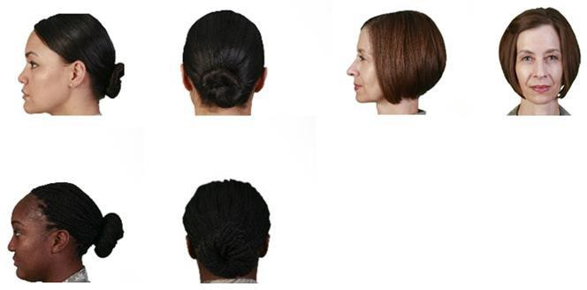
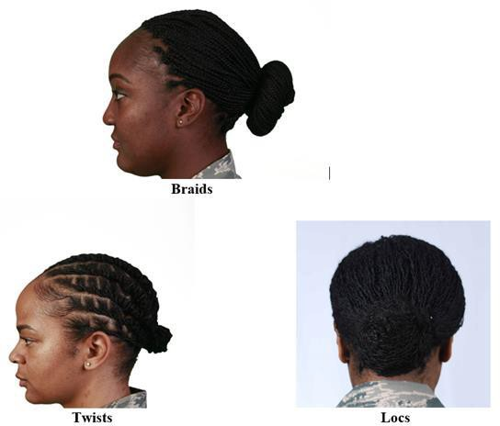

Attachment 6
7.12. Specific Male Cadet Grooming Guidelines. (See Figure 3.1)

Hair-Male. Tapered appearance on both sides and the back of the head, both with and without headgear. A tapered appearance is one that when viewed from any angle outlines the member's hair so that it conforms to the shape of the head, curving inward to the natural termination point without eccentric directional flow, twists or spiking. A block-cut is permitted with tapered appearance. Hair will not exceed 2 ½ inches in bulk, regardless of length and ¼ inch at natural termination point; allowing only closely cut or shaved hair on the back of the neck to touch the collar. Hair will not protrude under the front band of headgear. Cleanly shaven heads, military high-and-tight or flattop cuts are authorized. Prohibited examples (not all- inclusive) are Mohawk, mullet, cornrows, dreadlocks or etched shapes and/or design. Cadets may have one (cut, clipped or shaved) front to back, straight-line part, not slanted or curved, on either side of their head, above the temple. Part will not exceed 4 inches length or ¼ inch width. Men are not authorized hair extensions. See Figure 3.1

    - Mustaches. Male Cadets may have mustaches; however, they will be conservative (moderate, being within reasonable limits; not excessive or extreme) and will not extend downward beyond the lip line of the upper lip or extend sideways beyond a vertical line drawn upward from both corners of the mouth.

    - Beards are not authorized unless for medical reasons, when authorized by a medical official, or as authorized pursuant to a request for a religious accommodation. Beard wear authorized for religious reasons are governed by AFJROTCI 36-2010. When authorized for medical reasons, members will keep all facial hair trimmed not to exceed ¼ inch in length. Individuals granted a shaving profile may shave or trim their facial hair to present a neat, clean, professional image.

Sideburns. If worn, sideburns will be straight and even width (not flared), and will not extend below the bottom of the orifice of the ear opening. Sideburns will end in a clean-shaven horizontal line. See Figure 3.1

  - Mustaches. Male Cadets may have mustaches; however, they will be conservative (moderate, being within reasonable limits; not excessive or extreme) and will not extend downward beyond the lip line of the upper lip or extend sideways beyond a vertical line drawn upward from both corners of the mouth. See Figure 3.1

7.17. Fingernails. Male Cadets are not authorized to wear nail polish.

7.18. Cosmetics. Male Cadets are not authorized to wear cosmetics.

7.19. Undergarments (Mandatory)

Attachment 6

Appropriate undergarments are required to be worn with all uniform combinations. Wear undershirt and underpants with all uniforms. Wear the white V-neck or athletic style tank top undershirt when wearing opened collar service uniforms only. Undershirt will be tucked into trousers. Undershirts will not have pockets.
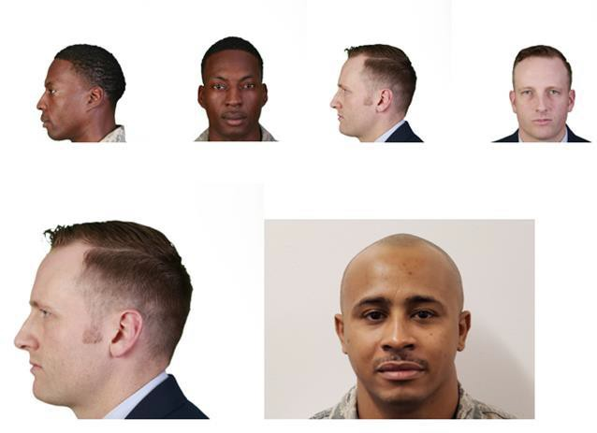
Figure 3.1. Male Hair Grooming Standards

Unauthorized hair for men.

Attachment 6
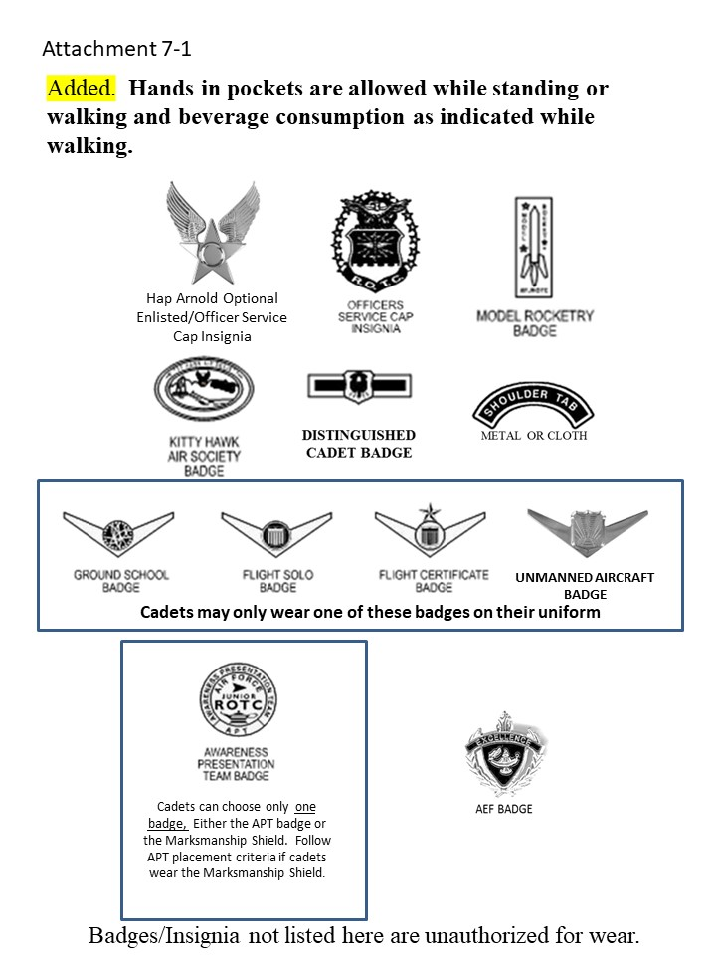
Attachment 7

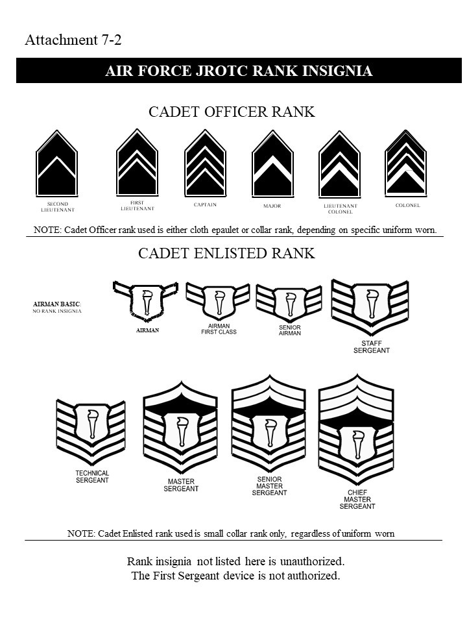

Attachment 8
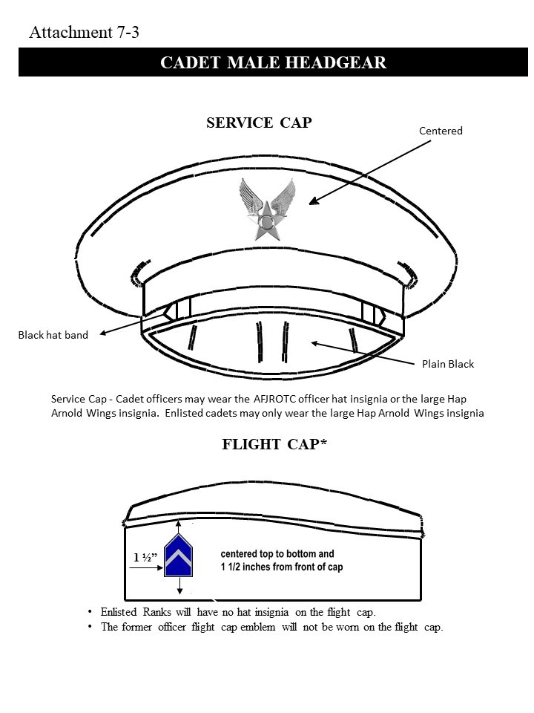
Attachment 9

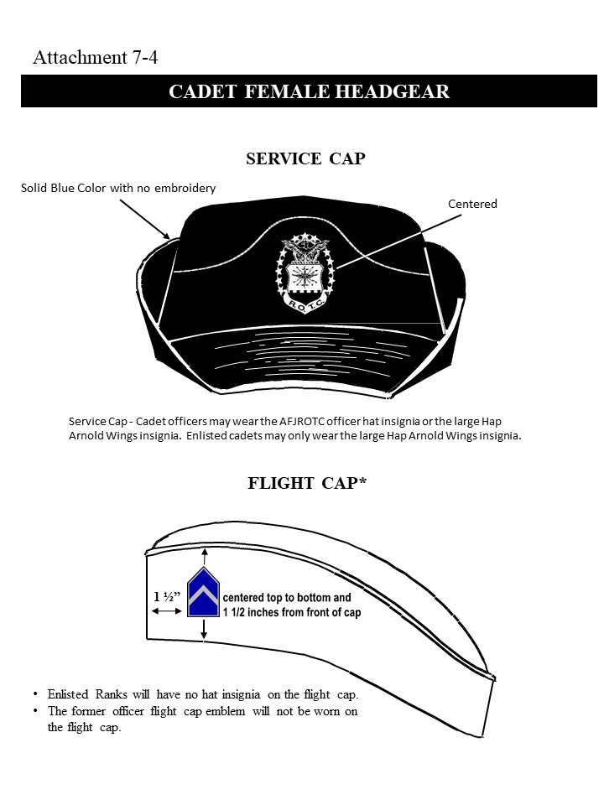

Attachment 9
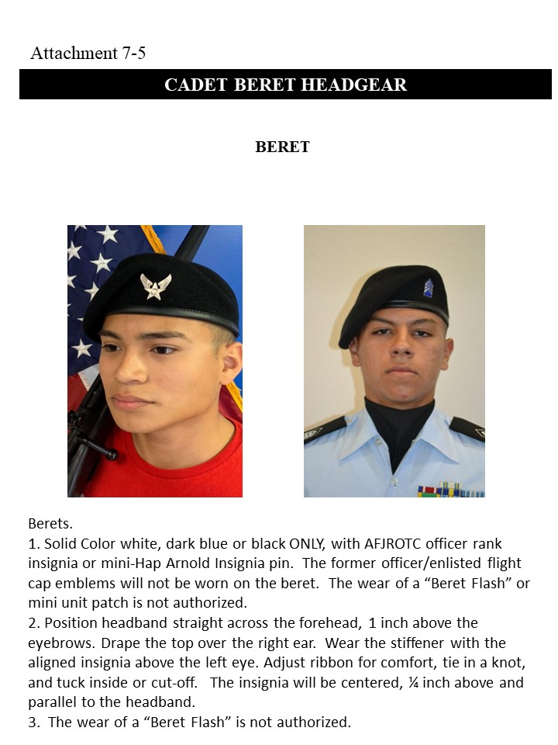

Attachment 9

Attachment 9
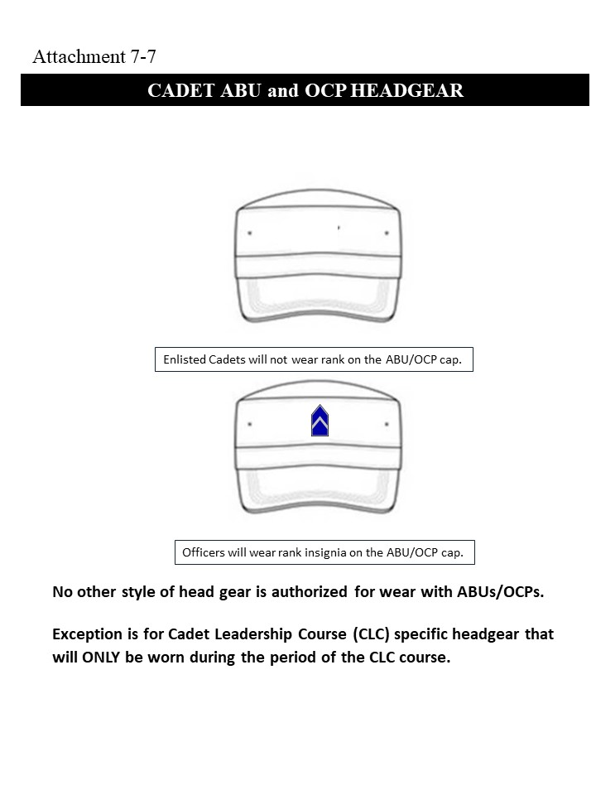

Attachment 9
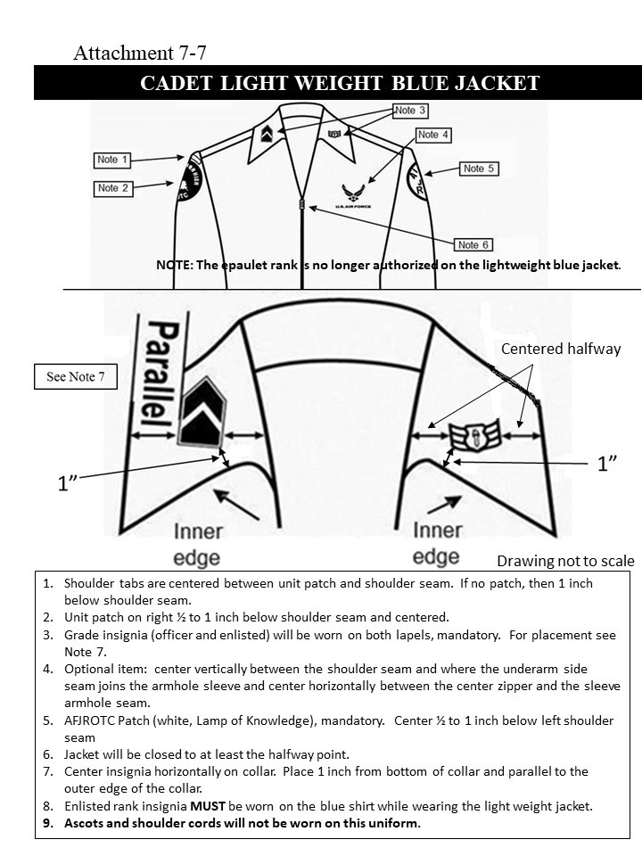
Attachment 9

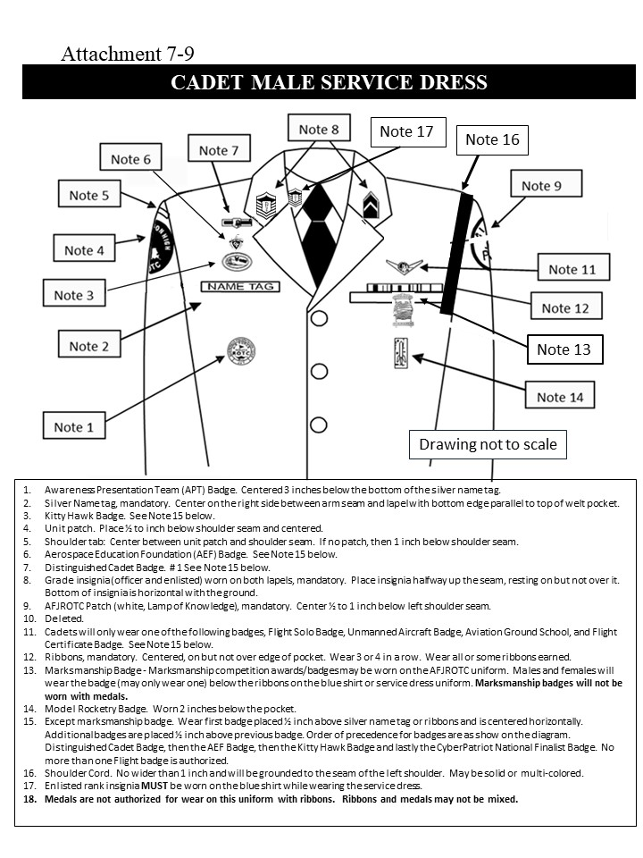
Attachment 9

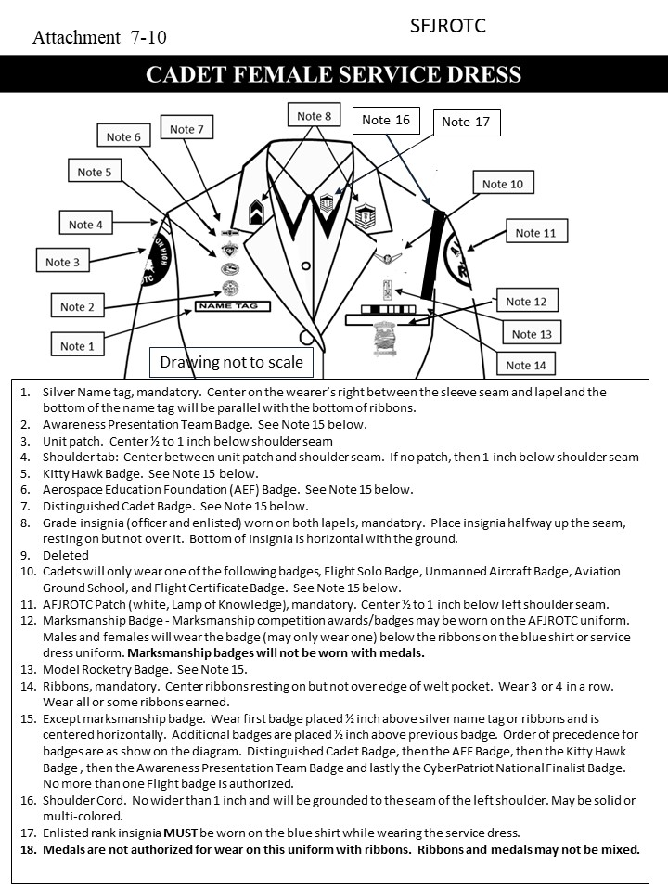

Attachment 9
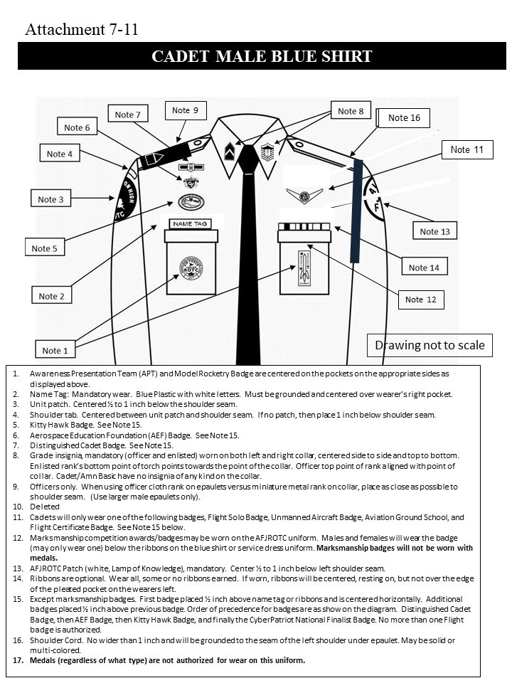

Attachment 9

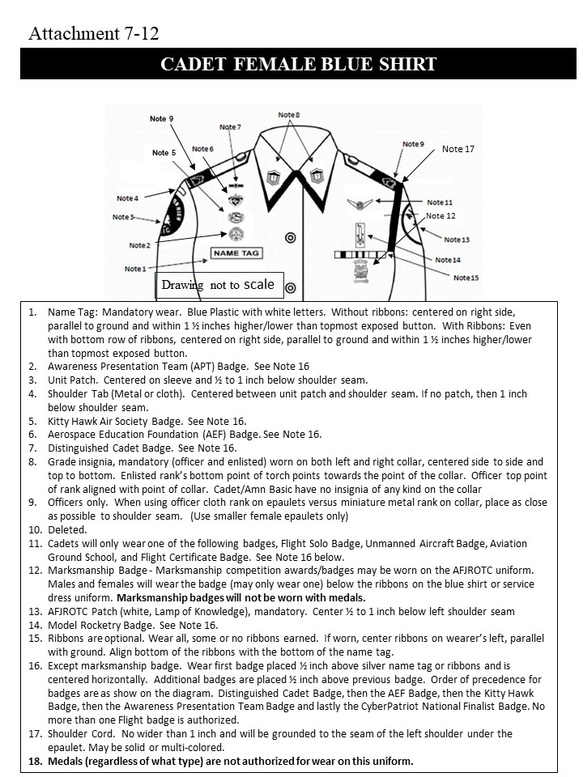

Attachment 9
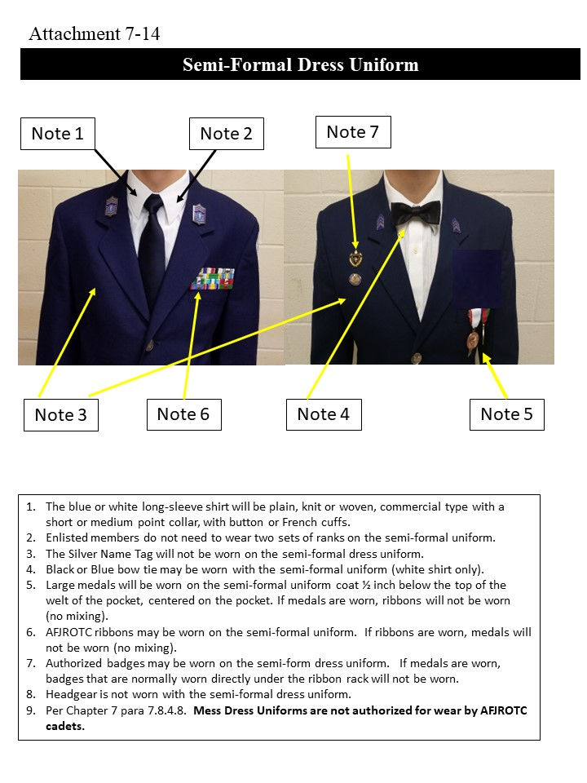
Attachment 9
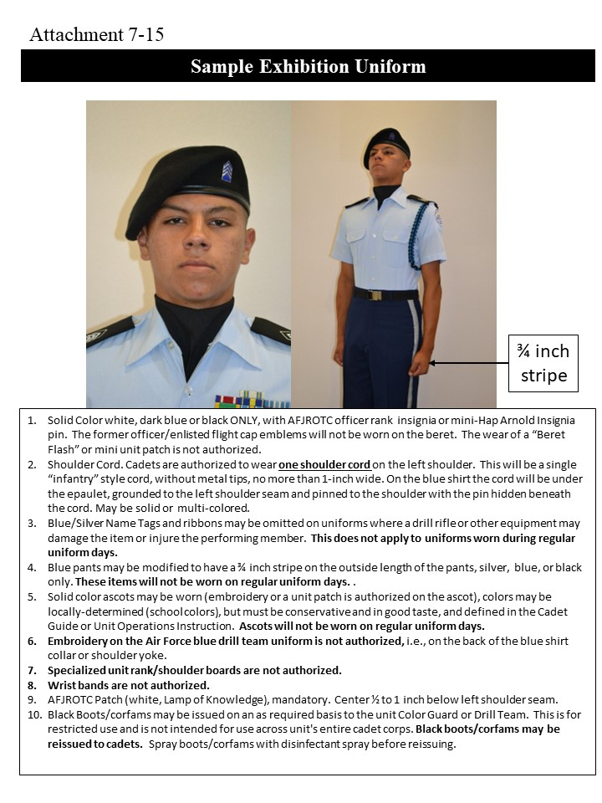
Attachment 9
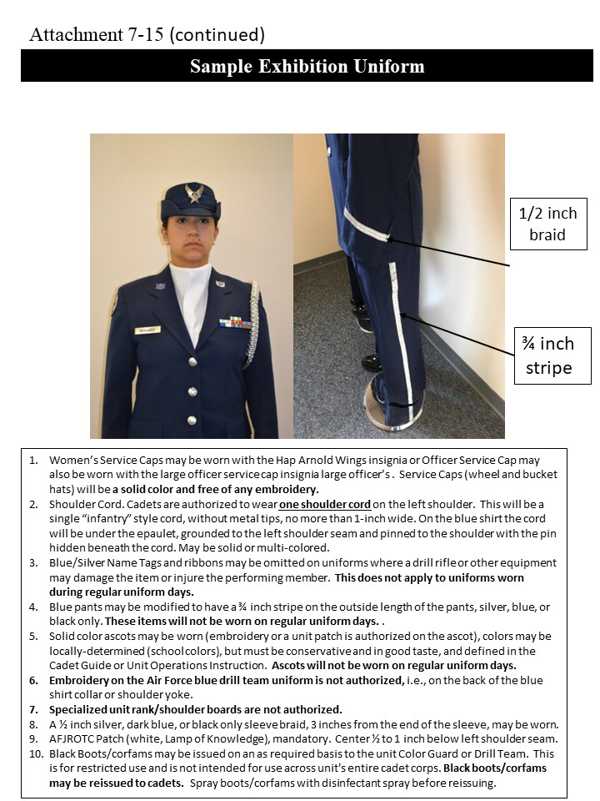

Attachment 9
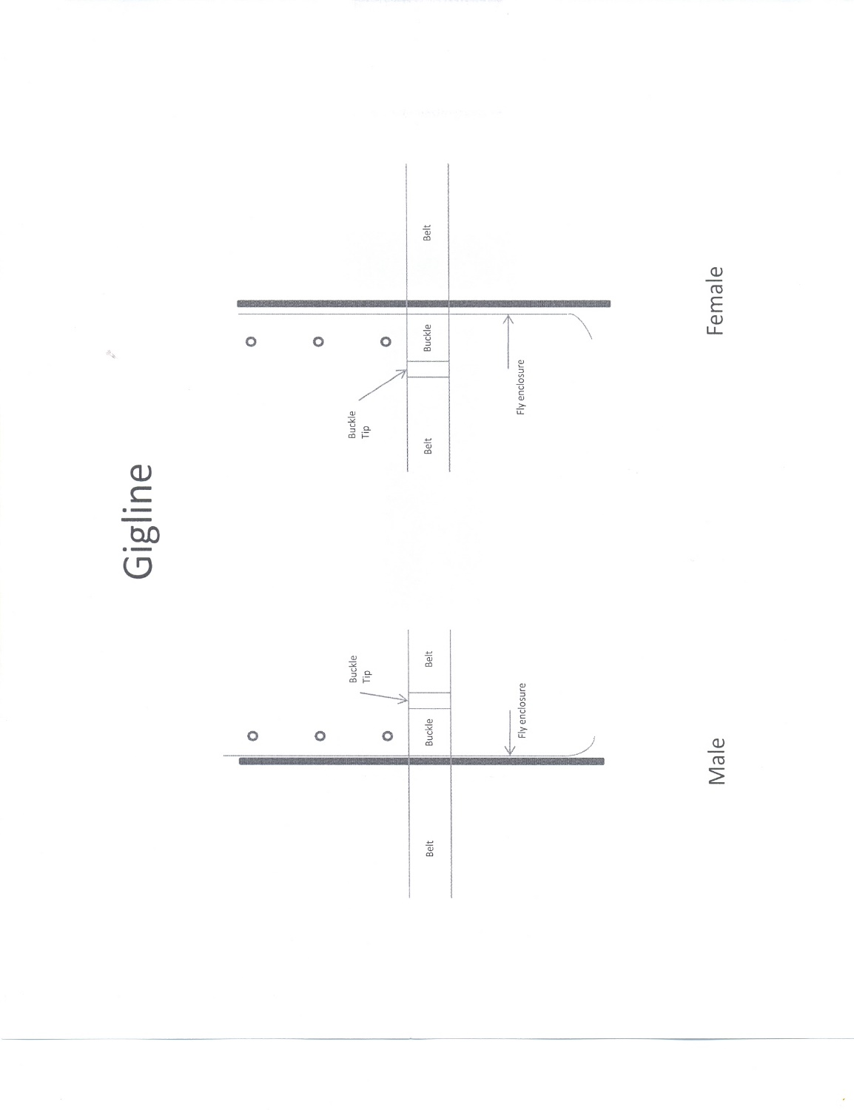

Attachment 10
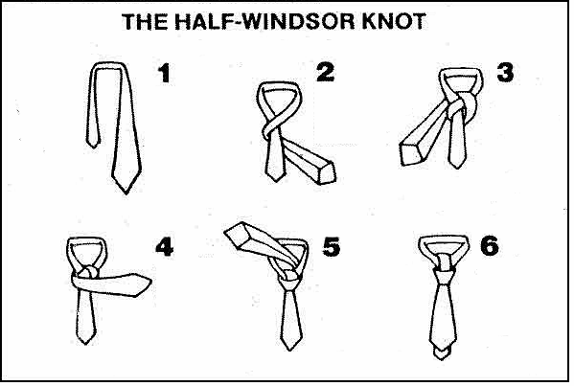

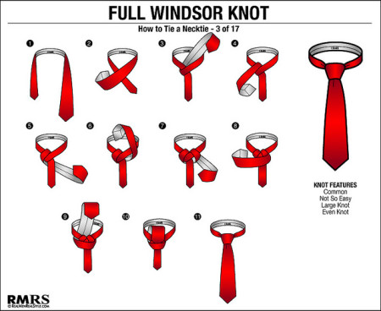

Attachment 11

Military Time/Phonetic Alphabet Chart

TIME |  | PHONETIC ALPHABET
Civilian | Military
1:00 AM | 0100 | A | ALPHA
2:00 AM | 0200 | B | BRAVO
3:00 AM | 0300 | C | CHARLIE
4:00 AM | 0400 | D | DELTA
5:00 AM | 0500 | E | ECHO
6:00 AM | 0600 | F | FOXTROT
7:00 AM | 0700 | G | GOLF
8:00 AM | 0800 | H | HOTEL
9:00 AM | 0900 | I | INDIA
10:00 AM | 1000 | J | JULIET
11:00 AM | 1100 | K | KILO
12:00 NOON | 1200 | L | LIMA
1:00 PM | 1300 | M | MIKE
2:00 PM | 1400 | N | NOVEMBER
3:00 PM | 1500 | O | OSCAR
4:00 PM | 1600 | P | PAPA
5:00 PM | 1700 | Q | QUEBEC
6:00 PM | 1800 | R | ROMEO
7:00 PM | 1900 | S | SIERRA
8:00 PM | 2000 | T | TANGO
9:00 PM | 2100 | U | UNIFORM
10:00 PM | 2200 | V | VICTOR
11:00 PM | 2300 | W | WHISKEY
12:00 MIDNIGHT | 2400 | X | X-RAY
 |  | Y | YANKEE
 |  | Z | ZULU

Attachment 12
30 Command Drill Sequence

1. Fall In 16. To The Rear, March, R

2. Open Ranks, March 17. To The Rear, March, R

3. Ready Front 18. Column Right, March, R

4. Close Ranks, March 19. Forward March, L

5. Present Arms 20. Eyes Right, R

6. Order Arms 21. Ready Front, L

7. Parade Rest 22. Column Right, March, R

8. Attention 23. Forward March, L

9. Left Face 24. Change Step, March, R

10. About face 25. Column Right, March, R

11. Forward March 26. Forward March, L

12. Right Flank, March, R 27. Flight Halt, L

13. Left Flank, March , L 28. Left Face

14. Column Right, March, R 29. Right Step, March

15. Forward March, L 30. Flight Halt (When heels come together)

Attachment 13

AFJROTC Cadet Creed

I am an Air Force AFJROTC Cadet

I am connected and faithful to every Corps of Cadets who served their community and nation with patriotism

I earn respect when I uphold the core values of Integrity First, Service Before Self and Excellence In All We Do

I will always conduct myself to bring credit to my family, school, Corps of Cadets, community, and to myself

My character defines me. I will not lie, cheat or steal. I am accountable for my actions and deeds

I will hold others accountable for their actions as well. I will honor those I serve with, those who have gone before me, and those who will come after me

I am a Patriot, a Leader, and a Wingman devoted to those I follow, serve and lead

I am an Air Force JROTC Cadet

Attachment 14

Mainland High School
FL-042 AIR FORCE JROTC STUDENT CONTRACT
2025-2026

APPLICATION AND AGREEMENT FOR:

_______________________________________________________ __________
(Print Last Name, First Name) (Flight)

- UNDERSTANDING: Belonging to the cadet corps is a privilege, not a right. The Mainland High School AFJROTC Instructors reserve the right to remove you from the program if you are not meeting the minimum standards spelled out in this contract.

- OBLIGATIONS AND CONSIDERATIONS: Participation in AFJROTC does NOT commit or obligate any student to military service. This is a citizenship program. However, a cadet who completes two or three years of AFJROTC may qualify for advanced rank upon enlistment in the US Armed Forces. For those considering college ROTC, both instructors can write letters of recommendation on behalf of AFJROTC cadets.

- AGREEMENT: (Cadet) To maintain the high standards of courtesy, personal conduct, and appearance required by the USAF and FL-042 as a cadet, I understand and agree to:

- Meet the standards of behavior, attitude, and courtesy established and taught by the
instructors.
B. I will wear the AFJROTC uniform on those occasions prescribed by the SASI. Uniform Day is normally every Wednesday. Refusal to wear the uniform on designated days or improper use of the uniform can result in removal from AFJROTC.
- I will maintain the uniform in a clean, properly fitted, and repaired manner. I will turn in the complete uniform upon demand. I am responsible for the cost of cleaning and loss, theft, or damage of uniform items. All uniforms must be returned at the end of the school year, unless otherwise noted. The following is the replacement cost for issued uniform items.

MALE |  |  |  |  | FEMALE
Coat | $175.42 | Tie | $6.77 |  | Coat | $175.42 | Tab | $10.27
Jacket | $125.01 | Belt | $5.74 |  | Jacket | $125.01 | Belt | $5.74
Shirt | $29.07 | Buckle | $4.39 |  | Shirt | $29.07 | Buckle | $4.39
Trousers | $83.38 | Flight Cap | $15.02 |  | Slacks | $84.04 | Flight Cap | $15.02
Shoes | $65.76 |  |  |  | Shoes | $65.76 | Skirt | $53.55
 |  | TOTAL | $510.56 |  |  |  | TOTAL | $568.27

- I will meet and maintain the personal grooming standards established by the USAF. I will pay particular attention to military hair standards (Male and female), facial hair, body piercing, tattoos, and body jewelry as described in the AFJROTC Cadet Guide.

Attachment 15

- I must maintain an acceptable standard of academic performance in all classes. I will complete all assignments given to me by my instructor. I will be active in classroom work and the co-curricular activities of AFJROTC. (Cadets should participate in as many extra-curricular activities as possible -- several ribbons are earned this way.) I understand at a final grade of “F” in AFJROTC is grounds for dismissal from AFJROTC.

- I will respond positively to other cadets who have been appointed to leadership positions. I will render proper military courtesies to instructors and other cadets with senior rank. I will be courteous. I will conduct myself properly when I am entrusted with a leadership position.

- I will strive to develop self-discipline and accept personal responsibility for my actions.

- I will take proper care of any materials/equipment provided by the USAF and return them when requested to do so.

- I will read, understand, and comply with the requirements and information provided to me in the FL-042 Cadet Guide.

- STUDENT SIGNATURE:_________________________________ DATE_____________

5. PARENTAL/GUARDIAN APPROVAL: I understand my daughter/son is enrolled in the AFJROTC Program and will encourage her/his participation. My child has read this contract, with particular attention to Paragraph 3, and understands the requirements of this program. I understand there is NO commitment for military service associated with participation in AFJROTC. I will help my daughter/son maintain the high standards expected of an AFJROTC cadet at Mainland High School.

PRINTED NAME OF PARENT/GUARDIAN____________________________________

PARENT PHONE #__________________________________________________________

PARENT’S SIGNATURE: ________________________________ DATE____________

Attachment 15

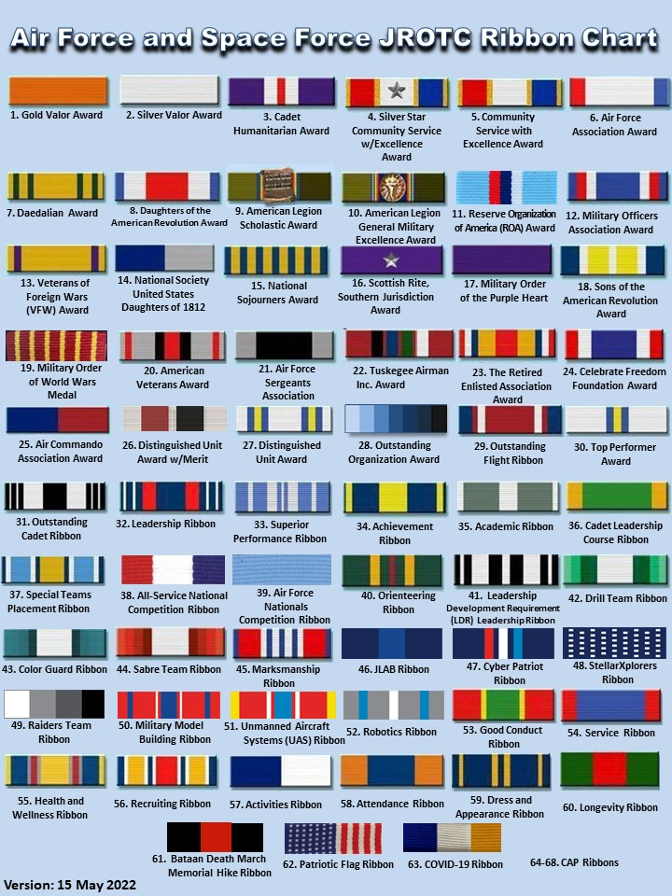

Attachment 16

